***At the Rexum’s Behest***

**Tone**: A gritty world with many flaws. However, while filled with hardships and adversity, I don’t want it to seem like joy or happiness is absent. Families exist, societies function well enough that they are still worth living in. However, inequality and violence are rampant, and the lands between settlements are supernaturally dangerous. To use a comparison, the times players will be part of would be synonymous to a typical world of a SoulsBorn game before its inciting incident.

Overall this setting has a much darker tone than previous campaigns such as *The Bleeding Realms* or *Medjia*. I’m hesitant to say it will feature “gritty realism” as the goal isn’t so much to make things harder than they should be in a normal campaign. The grittiness and realism will be inspired by our own human history, which during times of war, plague, famines, the worst aspects of our species have been on display. But even so, history tends to also focus on the terrible, ignoring the good and mundane that exists at the same time.

While things like murder, massacres, and death will be present, the details of victims is not the focus. There won’t be graphic descriptions of violence, only mentionings of it as it pertains to certain scenes.

Lastly, player death is very much on the table. No punches will be pulled with combats or NPCs. Characters can very well die, even in session 1 depending on their actions. With that said, the DM will not go out of their way to try to kill players. The world exists as it does and it is the players’ choices that will decide their path and their fate. Not every fight can be won at the time and it’s up to the players to determine what they want to do to complete an objective.

**Theme**: player choice is key to how the story will unfold. Corruption, deceit, free will, loyalty, and morality will be the major components at play. Factions within and outside of the Dominion will be working towards their goals starting from session one, but it’s not to say that it’s on the party to tackle every issue. However, similar to most RPG video games there will be times where choices will be locked in and said choices will have cascading effects that can lead to different outcomes.

**Setting**: the continent of Skediwen, pronounced Ss-kay-Dee-wen. It is European in terms of geographical diversity, though much more Germanic/Scandinavian in terms of cultural inspiration.

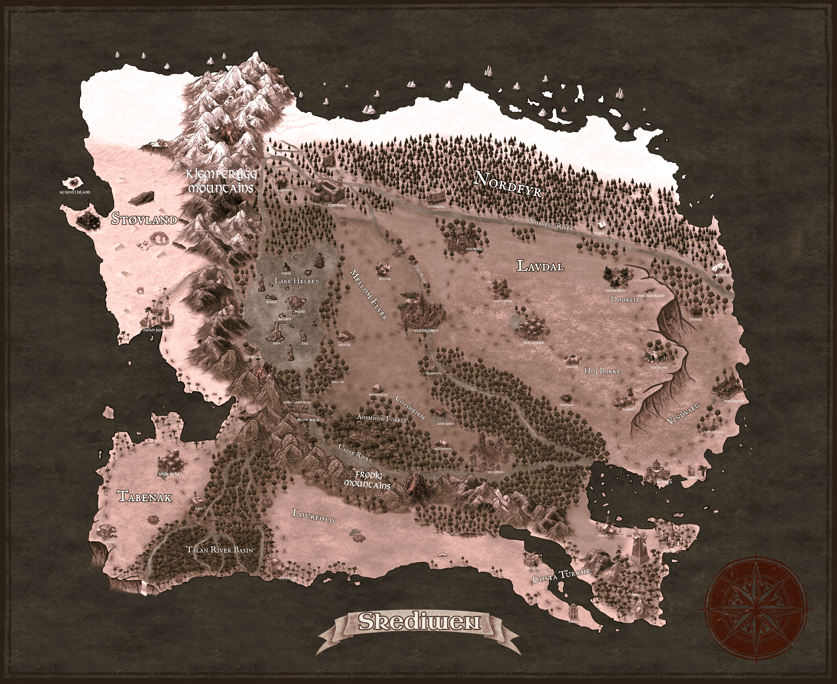

**Brief**: The continent of Skediwen is ruled over by a ruthless head of state known as the Rexum. The Rexum is a hulking man who through special gifts from the gods, was able to unify much of the continent as it had been engulfed in wars for at least the last 500 years. While a skilled conqueror, the Rexum has not been a great ruler and as such, the peoples under his rule have suffered greatly over the years. These problems led the gods to take back their gifts as they no longer felt the Rexum had the right to hold them. However, while trying to retrieve the Divine artifacts, a scuffle broke out and the God of War was slain in the process by the Rexum himself.

All but the war god’s sword were stripped away, and with it, most of the divine energy that had essentially kept the Rexum perpetually young and in peak condition. Though even without the artifacts, he was and is still a powerful individual. Additionally, as one of the divine items still remains in his possession, the Rexum has retained enough divine energy to keep himself in power. Still, word has gotten out that he has been weakened, many believing that the gods themselves have revoked his right to rule. Rebellions have popped up all across his domain, waiting for any cracks in the Dominion to show. However, this isn’t the only crisis currently engulfing the continent. Word has it that strangers from across the ocean have landed on Skediwen’s southeastern shores. With them they’ve brought along a strange new religion and an army of “beast men”. At the head of theses mysterious strangers is a large and oddly shaped humanoid entity referred to as the “Living God”. While their true intent is still yet unknown, the foreign forces have begun occupying territory on the continent, and converting those they encounter into their cult.

With the flames of chaos starting to spread, the Rexum’s grand Vizier has devised a plan to reprocure the divine artifacts taken from the Rexum in order to ensure they do not fall into the hands of the enemy, and to aid in the coming conflicts. The current theory is that since the artifacts were crafted for mortal use, on the mortal plane they still remain. In fact, one artifact has supposedly already been located, though it now lays deep within territory occupied by the foreign invaders. Though for the moment, Dominion intel suggests that the invaders themselves seem to have no idea this item exists. Not wanting to expose the artifact’s existence, the grand Vizier has devised a plan for a small group to sneak into occupied territory, retrieve the item, and return it to the Rexum’s court. Leaders of all kinds still allied under the Rexum’s Dominion have been called upon to nominate their best up and comers for a place on this special task force. With all nominees directed to meet at the Rexum’s court, before the Rexum himself, our players will be introduced and their mission given.

***Ages***

**The Unknowing Age** - prehistorical times that almost nothing is known about.

**The First Age** - the appearance of earliest sapient cultures and societies. Magic is discovered and at its zenith was integrated in nearly all aspects of life. Shortly after, the age falls into decline.

**The Demonic Age** - a time where ancient powerful demons ruled the continent, enslaving its inhabitants, or exterminating them altogether. It was an age full of wars and strife as different demons fought against one another for power. The age came to an end when the dragons first appeared on the continent.

**The Ashen Age** - a period that began of ash and flames as the demon lords were either defeated or weakened to the point of losing nearly all influence. The dragons took towards establishing a loose empire that itself only lasted a little more than a century. Infighting amongst differing draconic clans led to more years of chaos and strife.

Much knowledge was lost during this time as the dragons preferred oral histories to written ones. The many great libraries of the demons were destroyed in their initial attacks. From what little survived, the species native to the continent were seldom given access to what had remained as the dragons feared it could result in their own downfall.

**The Dawning Age** - just as the dragons had come from lands afar, so arrived the titans a few centuries later. These massive giants came to settle in Skediwen, quickly coming into conflict with its ruling class, the dragons. After nearly half a century of fighting, much of what remained of the already fractured draconic empire was stamped out. The titans and their descendants would go on to become the de facto rulers of the continent for the next millenia.

While the titans, and later, the giants, were rulers over Skediwen, their rule was far more decentralized than their predecessors. The small folk provided little in the ways of convenience for them, so rather than enslave the masses the giants chose to mostly leave them to their own devices while demanding grand taxes be paid for their safety.

With each passing generation the children of the titan clans grew shorter and shorter in stature, eventually ending up around the sizes they are today. As for the titans themselves, most would end up disappearing for one reason or another. As for why, it is only speculated. Many believe they’ve simply entered into a state of hibernation and will one day return, while the remains of others have been discovered having merged into the landscape to a point a titan skull could easily be mistaken for a cave.

**The Divine Age** - While the great divine’s existence was well known of throughout all the known ages, the entity did little to nothing in terms of interfering with affairs on the continent. That was until the 9 gods (before the existence of Cierripeti) established their presence. Claiming to be the children of the Great Divine, the gods destroyed the remaining titans, and drove the giants themselves to scatter out on the frontiers. With their foothold secured, the gods began sharing knowledge and supporting the mortal species in building their own independent civilizations and societies.

For roughly 500 years the continent knew a peace it had not seen since the first age. Though, as with the first age, that peace would not last. As civilizations grew, so did the conflicts among them. As the differing societies began to compete with one another, political relationships quickly began to fall apart, resulting in wars breaking out near everywhere. The gods themselves became divided on what, if anything should be done to curtail the decline of peace and civility as some believed they should intervene and put an end to the rivalries and strife, while others felt it was simply part of a natural cycle that needed to be left to work itself out. When the first Great Kingdom War broke out, the gap between the “Civil” and “Wild” gods widened, leading all the gods to distance themselves from direct intervention in mortal affairs, giving them the reigns to finally govern themselves in over 2250 years. This “divine exodus”, or “ trial of exultation”, depending on which philosophy one ascribes to, swiftly brought an end to the Divine Age.

**The Discordant Age** - the current Age on the timeline has been riddled with wars and strife amongst mortal kind. Nations, kingdoms, empires; all have risen and fallen during the past 450 years as societies and civilizations have fought against each other for dominance, control, and survival. The civil gods had each worked to try and lessen conflict and bring peace to the mortals, but were barred direct involvement by their wild brethren.

This Age has been further split into two eras. The first era is known as the era of strife. As the many wars and conflicts played out, it eventually whittled down the number of states to just seven. For at least a century more, these seven kingdoms/countries would remain at a stalemate as none seemed to have enough strength on their own to swallow their neighbors. However, while little would be gained in territory during the stalemates, much would still be lost as villages and towns along the borders would often come under fire from raiding parties or rival nations. The peasantry suffered the majority of the death and destruction, all the while the Aristocracies grew gluttonous behind large city walls. Being fed up with the state of affairs, the civil gods decided to exert their will over the mortals by means of choosing a “champion” to represent them. Their champion would be decided to be a young warrior of exceptional skill named Osric Vidstrum. To ensure the success of their chosen, each civil god created a magical item imbued with a small portion of their divine essence and gifted them all to the warrior. As a stipulation for reviving these gifts, young Osric was instructed to bring about peace on the continent by uniting all under one rule. Armed with five holy artifacts, Osric was able to do just that via a ruthless and bloody rebellion he led starting from his homeland, eventually spreading across all seven of the great nations, bringing each one of them to their knees. With the War of Unity over, the second era of the Discordant Age had begun; the Frangible Era.

While a skilled conqueror, Osric, now crowned as the “Rexum”, was not a great ruler during peacetime. The peoples under his rule had suffered greatly over the years due to mismanagement (some say purposeful) which has led to increases in banditry, famines, and plagues. To cope and reach for any kind of salvation during these desperate times, some had turned away from the gods who gave them a tyrant as their representation on the mortal plane. Small sects of obscure beliefs grew to become the salvation for those desperate and yearning for change. Others had chosen to take fate into their own hands, forming rebellious militias with the intent to overthrow the establishment and self govern.

Through the decades following the War of Unity, the new mounting problems convinced the civil gods to take back their artifacts from the Rexum as they no longer felt he had the right to hold onto them. However, in trying to retrieve the divine artifacts, a scuffle broke out, and in an unprecedented turn, the God of War was slain in the process by Osric himself.

While an unexpected outcome, the other civil gods were successful in stripping away their personal artifacts, leaving all but the war god’s sword in the Rexum’s possession which for reasons unknown could not be separated. However with the slaying of Karz was a major shock to all, the encounter noticeably had an effect on the great Rexum. With the removal of four of the five divine artifacts, the Rexum suffered by aging decades in a matter of days. This proved to be the catalyst many needed to begin their rebellions in earnest. Never before has the Rexum been as vulnerable as he is now, and as in the beginning of the Discordant Age, many seek to use this opportunity for their own gain.

**Campaign Pertinent History:** The lands of Skediwen are awash with strife and suffering. Nearly a century ago, a warrior arose, wielding armaments of the gods, who struck out at the old empires and kingdoms and put them all under a new singular order, that of the Rexium’s Dominion. Through violence and bloodshed peace was obtained, but it was only a temporary one. The great warrior, now ruler, or “Rexum” of this unified state may have been a great leader in times of war, in peace they’ve proven time and again to be erroneously unfit. It was not long after the final kingdom fell in what would be known as the War of Unity that the great Rexum was bestowed another title by those under his boot; the Tyrant Lord.

For many years after the Great Unification, rebellions sprang up all over the dominion only to be met with the crushing forces of the Tyrant Lord. For the Rexum, battle and bloodshed were what he had known best. Many believe that the Rexum’s mind has fractured as a result of decades of divine energy coursing through the unfit vessel of a mortal. This energy has been both slowly destroying and preserving him inside and out. Through either purposeful mismanagement, or blatant self sabotage, the Rexum’s Dominion would never cease to be at war despite the War of Unity having ended long ago. Blights, famine, disease, all are rampant and used as motivators for those under the Rexum’s thumb to keep them in a constant state of fight or die, all to satiate his lust for new enemies to conquer.

The act of purposely destroying the people of Skediwen was the final straw for the gods who had originally lent their power in hopes of ending mortal wars once and for all. In an unprecedented event, the five of the prime deities descended from the heavens to meet with the Rexum and demanded the return of their vestiges. In maniacal arrogance, the Rexum refused to do so, prompting the God of War and Virtue, Karz, to put the mortal in his place. With a great display of his power, Karz struck out at the Rexum, creating a chasm where the high throne once stood from the sheer force unleashed. However, just moments later as the dust and debris began to settle, from the depths of this newly formed chasm lunged the Rexum towards Karz, running him through with the very same sword he received from the god of war. To the shock of all present, the Rexum pierced through the heart of Karz, mortally wounding him. The god fell to a knee, bleeding out golden blood as the Rexum raised his blade above Karz, preparing a final blow. However, before he was able to bring down the sword, the other gods present took action and quickly subdued him.

Held bound by Cirrepeti, the god of pain, torture and punishment, each item of divinity was ripped away and returned to its original benefactor, all except one. Try as they might, the sword of Karz remained firmly within the Rexum’s grasp as if it were now bound to the mortal. Karz, now having fully collapsed onto the floor, began to melt as if he were made of wax, quickly growing the pool of the divine golden blood. Suddenly, a loud echo bellowed throughout the throne room, blowing out windows and piercing through the Rexum like a thousand white hot needles. The standing gods immediately grew expressions of concern, and within a moment later the room filled with a bluish white light and the four remaining gods had all vanished. The Grand Divine, the entity above all of creation itself had forcefully removed the remaining gods from the Rexum’s throne room.

Freed from his binds, the Rexum fell to the floor, severely weakened by the sudden removal of the many powerful artifacts that had kept him fit and ageless. However, still in possession of the blade of Karz, the Rexum was slowly able to rise to his feet in triumph. Lording over the now golden puddle that once was a god, the Tyrant Lord cursed out at the gods before turning to celebrate his act of deicide.

While the fall of Karz shook all of Skediwen, it also marked a moment of change within the Rexum’s Dominion. The Tyrant Lord, while still powerful, was not the same man he had been prior. His body would age about 30 years over the course of just a few days. Despite being able to do the impossible of slaying a god, his feat drew far more outrage than expected across all of Skediwen. His armies, once unmatched by any force on the continent, would suffer a great loss of soldiers and leadership due to a refusal to continue serving a blasphemous King. As the man known as a god amongst mortals was now seen as greatly weakened, many saw this as an opportunity to rise up. No longer was the Tyrant Lord seen as invincible, as now all knew that this god amongst men was no longer held in favor by the gods.

In the year 84 TC, internal strife was disrupted with the arrival of a mysterious entity to Skediwen from somewhere far across the sea. Standing 10 ft tall, adorned in long, flowy white and gray robes, and a silver helmet with a golden corona, this mysterious entity has been referred to as the “Living God” by its followers. Accompanying this stranger were dozens of ships carrying worshipers of the quasi deity, eager to spread their faith through conquest and slaughter. The zealotry of these adherents has led them to claim large swaths of territory in a relatively short amount of time. Many attribute these swift victories to the Living God’s “awakened”; mortal creatures stripped of their consciousness and transformed into beastial marauders.

**Campaign Setting Adjunct:** There are no restrictions specifically regarding species as the overall makeup of the population will be proportionate to what the players choose. Humans however will be the default and most populous. Every other species will have some sort of lower status than humans.

All players will be from Skediwen, with the wider world being a mystery to all who call the continent home.

A call for a specialized task force to be formed by a selection of high potential recruits has been requested to meet at the Rexum’s throne for a yet to be discussed assignment. All players will be part of the Dominion and sponsored by one of the leaders of the factions listed below, outside of the Rexum and their Vizear.

Players should not hold traditional ideas of the nature of creatures from the outer planes like celestials, devils, and demons. Devils, for example, are servants to the gods as much as celestials. Demons however are their own separate thing.

***Factions***

The Dominion, AKA the faction of the “Rexum”

Led by Rexum Osric Vidstrum (politically by Grand Vizier Tharon Lodroth)

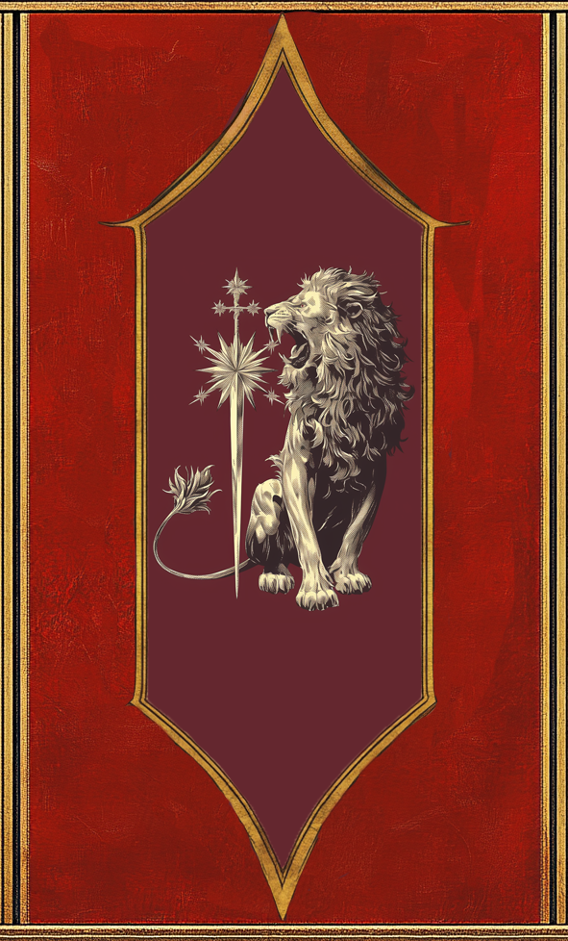

Players all belong to the faction of the Dominion. There are many facets to what makes up the Dominion, the biggest and most influential being the Orthodoxy and the military.

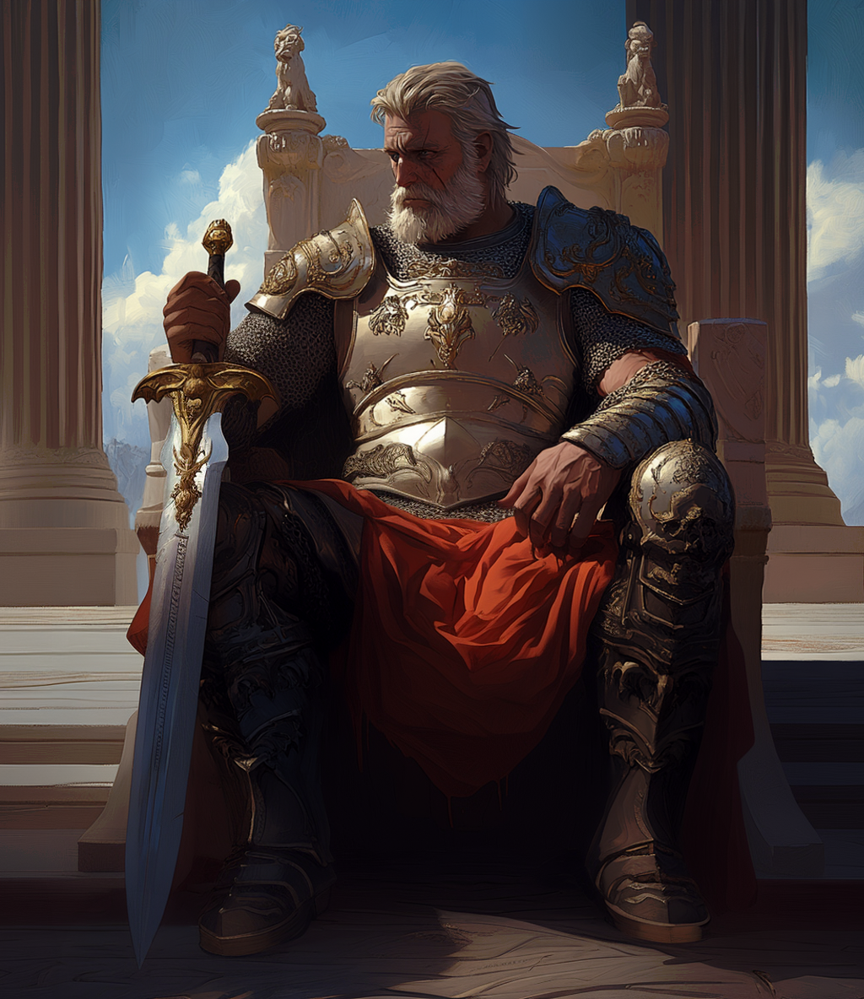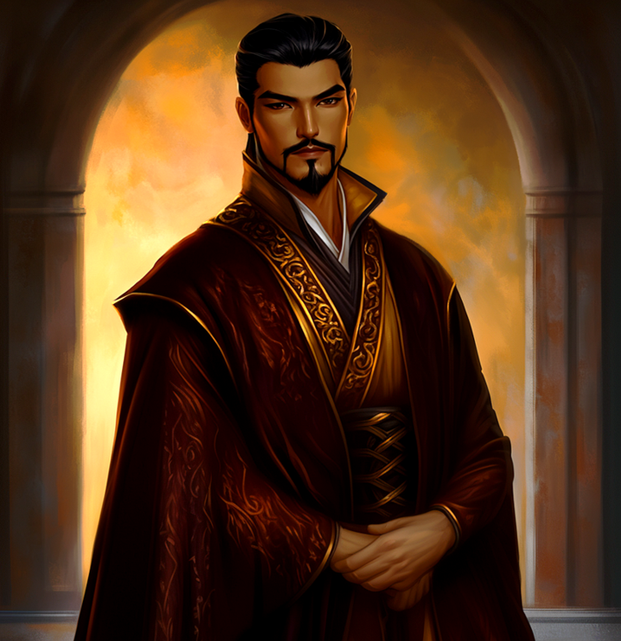

**The Orthodoxy**

Led by Grand Vicar Rynar Ovlav

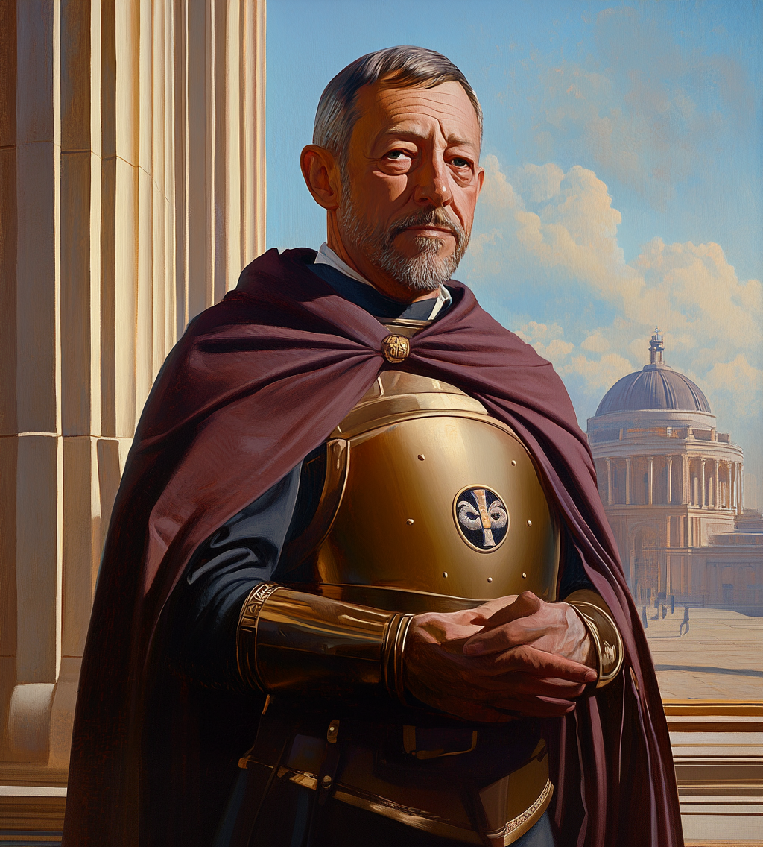

The formal religious apparatus of the Dominion, it has existed prior to the War of Unity, but never in such a centralized state as it is today. With the removal of borders came easier control and administration of smaller and semiautonomous parishes. With a centralized hierarchy being formally established, the orthodoxy has become a major influential wing of power.

As the Rexum was technically anointed by the gods as their champion, he was given some authority within the Orthodoxy itself. However, due to recent events the Rexum has fallen out with many within the Orthodoxy as he is now viewed as no longer having the favor of the gods. This combined with the Rexum’s personal turn against the gods has created tension between the himself and Orthodoxy leadership. The Rexum is powerful, both physically and politically, and while stripped of most of the divine artifacts, his possession of Karz’s sword does still give him some legitimacy as being spiritually relevant. A small minority within the Orthodoxy view the Rexum as either the new god of war, or enough of a threat that if pushed could drive mortals into a war against the gods themselves. With times being as chaotic as they have become, the official stance for the Orthodoxy is to keep the status quo rather than risk making a move that could spell their own downfall.

Within the Orthodoxy is a strict hierarchy of leadership, but there are also lesser known subdivisions that undertake specific duties outside of the main spiritual process. These groups operate based on specific guidelines established by the orthodoxy and ultimately answer to the Grand Vicar in times of uncertainty.

* Inquisitors
* Led by Grand Inquisitor Handor Sigori

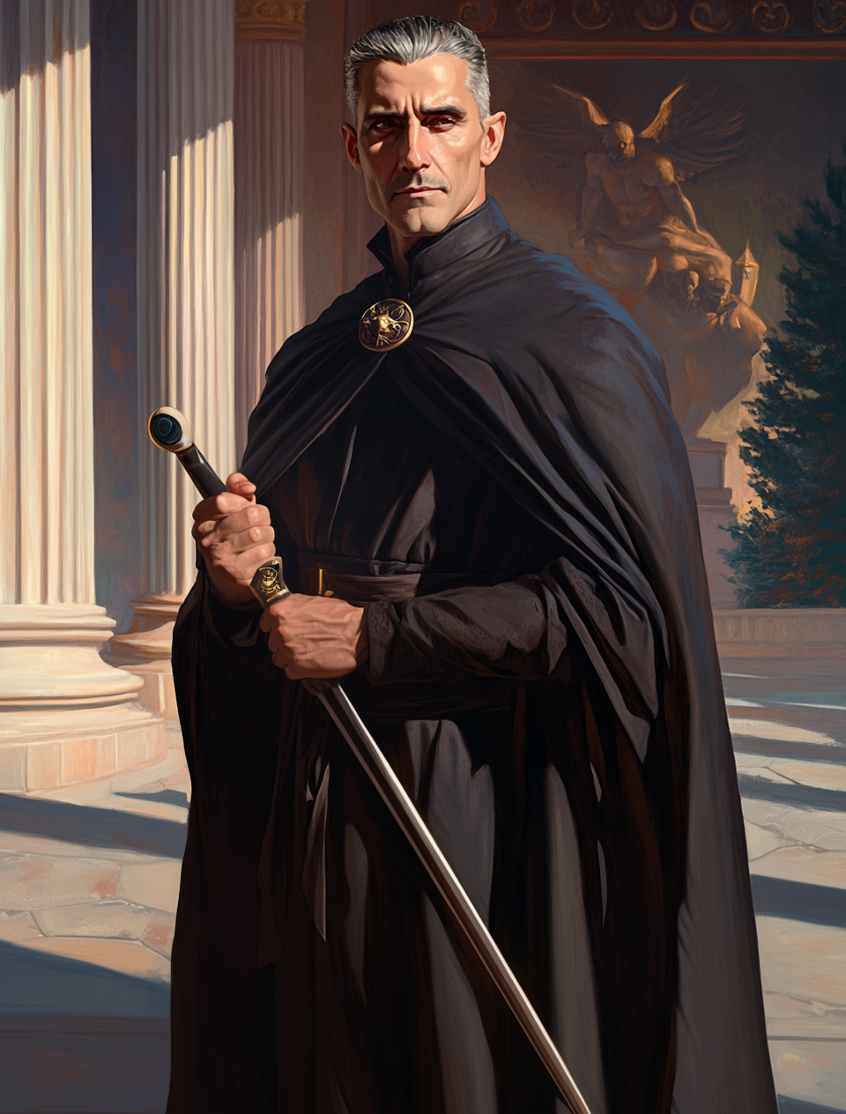

As the name indicates, inquisitors are those who lead inquisitions against potential heretics and aim to maintain the order within the orthodoxy itself. While clearly a political entity despite its claims of it only being concerned with spiritual matters, the orthodoxy has its own share of internal strife as members within jockey for power. The inquisitors are meant to be a neutral counterbalance to any attempts of destabilization within the church.

* Templars
* Led by Exarch Sigrid Fremdell

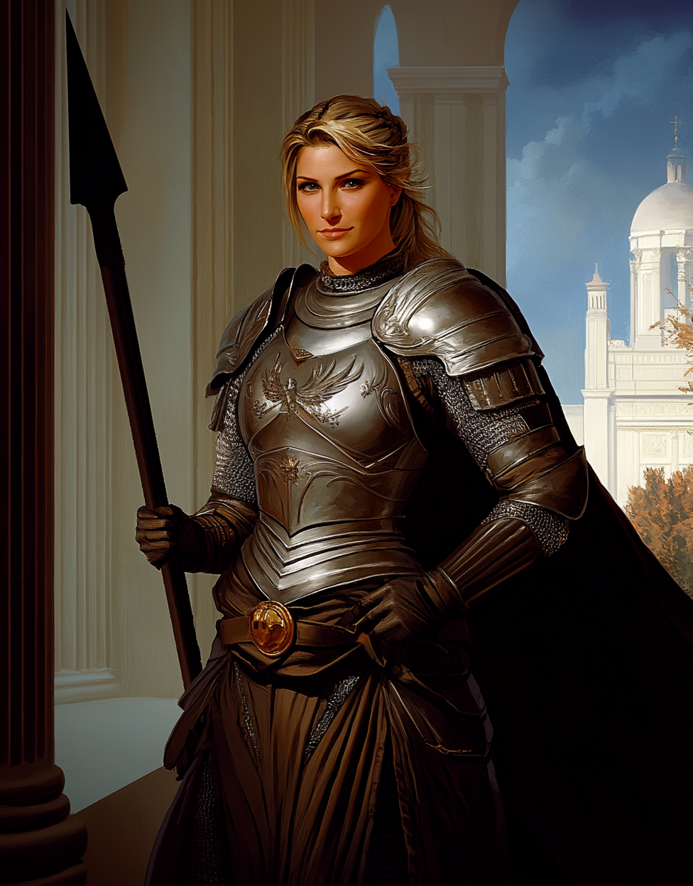

The Templars are a semi militant arm of the Orthodoxy. While inquisitors are able to dispense justice via investigation, for larger and more dangerous cases the trained holy warriors of the orthodoxy are sent in to pass judgement. Typically the Templars work based on orders from inquisitors, but in certain situations the Templars have been known to act outside of their purview.

* Cathars
* Led by Monsignor Ludvig Kiyavir

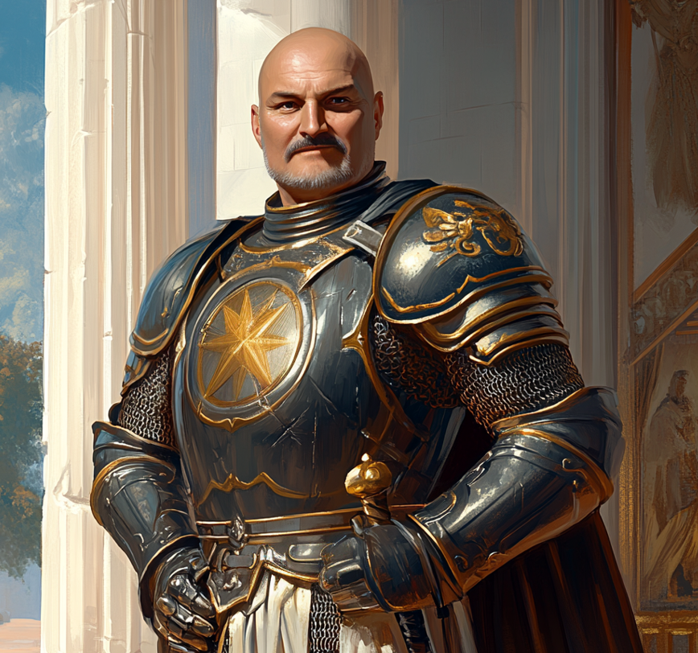

The Cathars are the most loosely organized group within the Orthodoxy. In fact, it may be incorrect to say that it is an organized group at all as most Cathars act independently from one another.

Cathars are a more archaic order known mostly for their mastery and direct access to divine magic from the gods. While not solely unique to their order, the majority of those who can call upon aid directly from the gods belong to the order of Cathars, having received training from a master in years past on how to properly channel their power. In years past before the centralization of the Orthodoxy, Cathars were leaders of faith in the smaller, typically isolated communities. Being a holdover from this time, Cathars still maintain a master and apprentice style of operation which has made those part of the order deeply loyal to one another, something many in the Orthodoxy see as suspicious and contrary to the purpose of the Orthodoxy overall.

**The Military of the Dominion**

The military has always been the prime focus of the Rexum. A strict meritocracy, proven skill and might has guided its leadership over the decades, creating a powerful and loyal force that has been instrumental in cementing the Rexum’s hold onto power. While there are certainly those who may hold their faith above their duty, there are far greater numbers who would gladly fight alongside the Rexum, even through the gates of hell itself if need be.

Within the military exist specialized divisions that have been allowed to act somewhat autonomously to further encourage innovation and competition. While they all hold the Rexum to be above them, there is little direct cooperation amongst them. Results are what matter most. As long as their goals are achieved, leadership operates in silos, always striving to gain an upper hand over their peers.

* **The Grand Army**

Three Main Divisions:

* Imperial Army - led by General Arnorr Dirstig

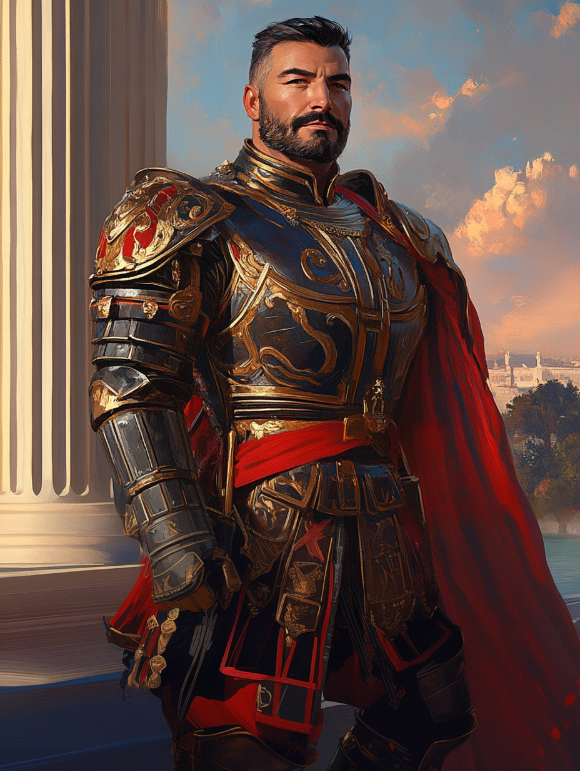

* Center Guard - led by General Rima Valci

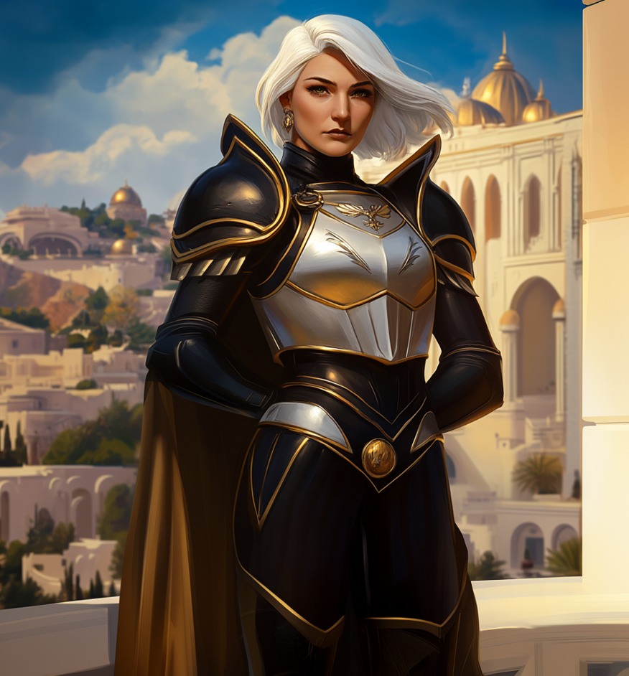

* Southern Legion - led by General Norman Brast

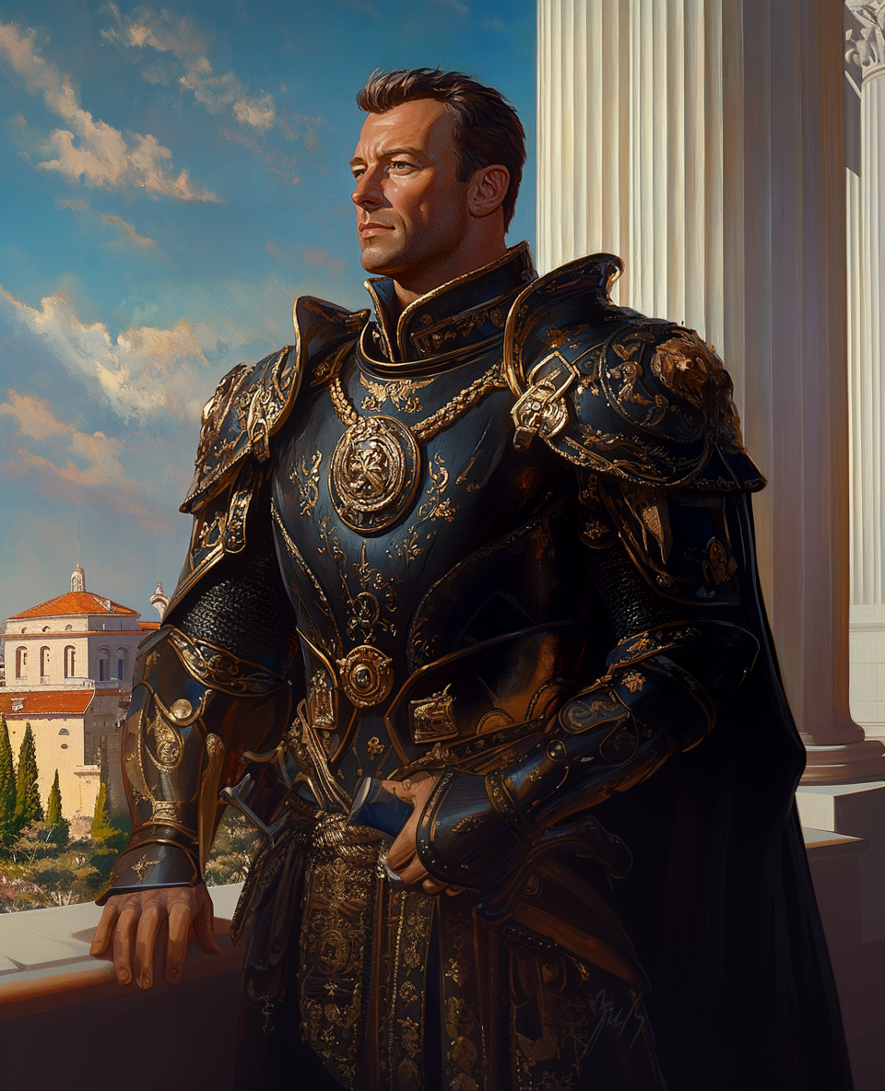

The grand army is the main arm of the Dominion’s military. It is where the vast majority of soldiers start their careers, and was the army personally led by the Rexum during the war of unification. While today's members are nowhere near the hardened and experienced soldiers that fought alongside the Rexum over 70 years ago, but due to the numerous smaller conflicts that have taken place since the war’s end, most of the grand army has some sort of combat experience under them, making them still the premier fighting force on the continent.

* **The Mage’s Corp**

Two Divisions:

* Wardens - led by Grand Magus Agatha Nexra

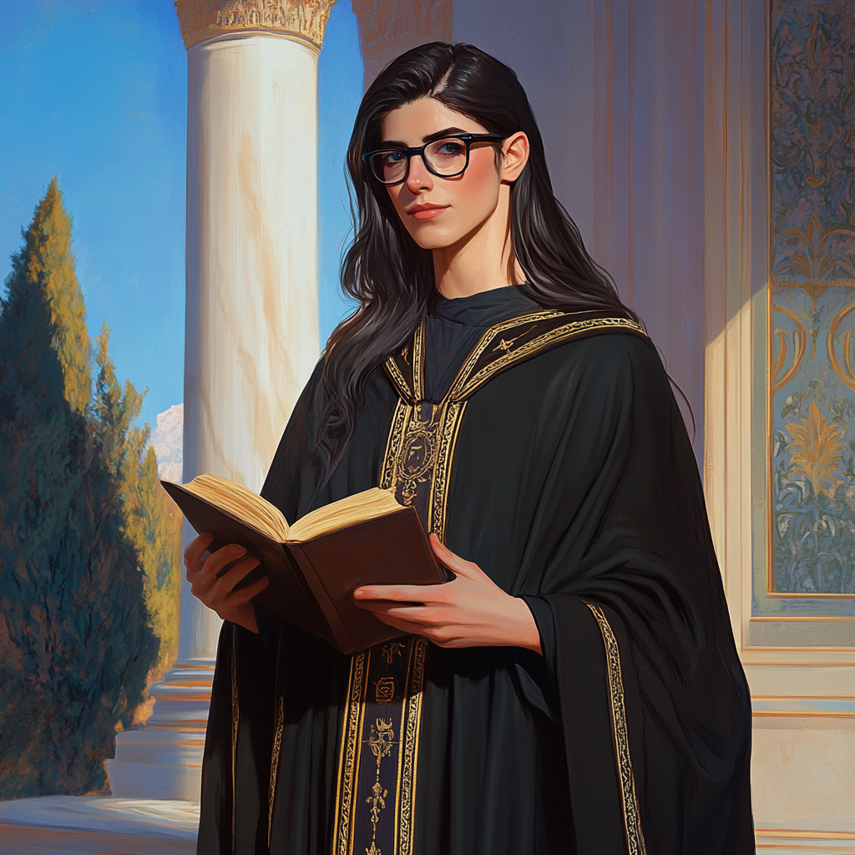

* Surges - led by Grand Magus Rollo Jesari

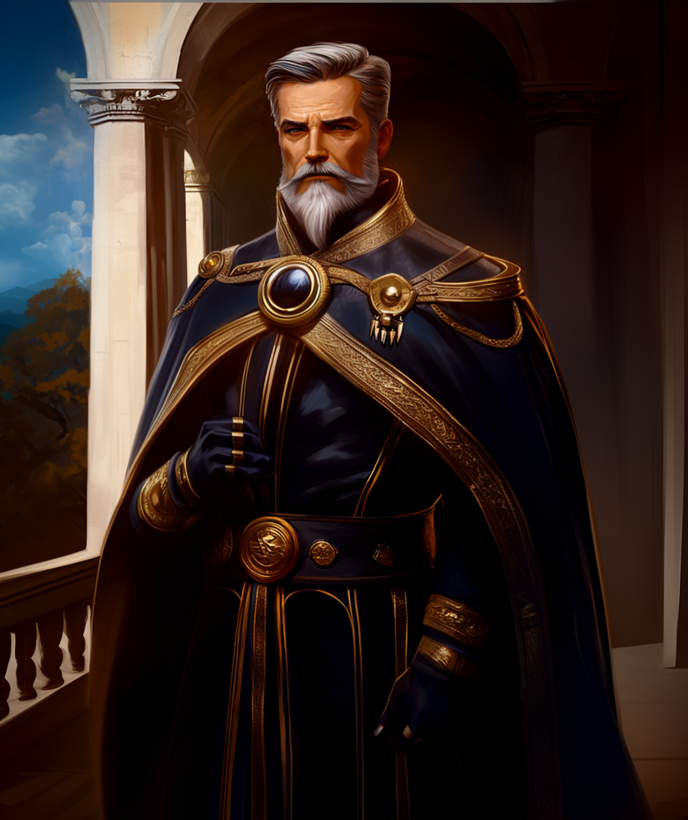

One Special Division:

* Castygien - led by Grand Magus Esper Hausa

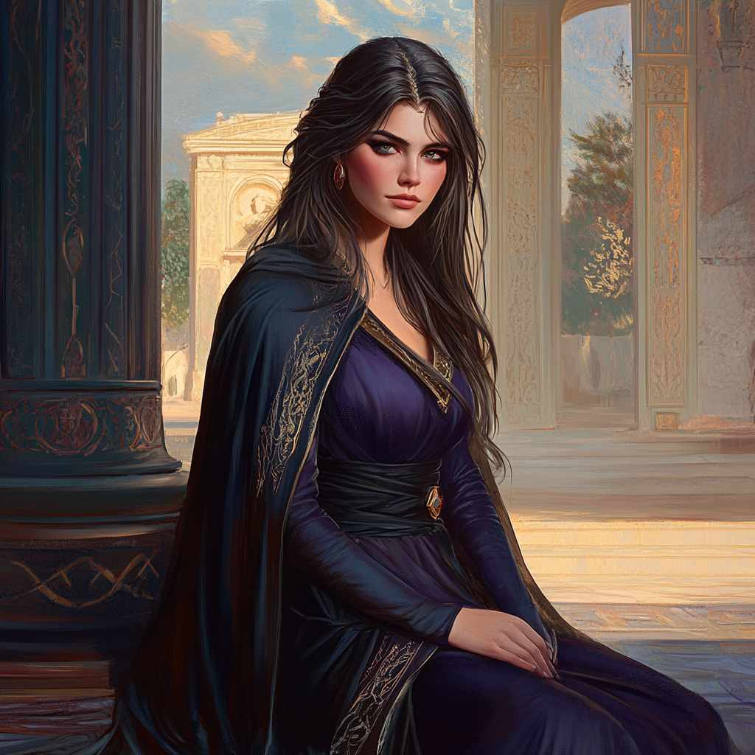

The Mage’s Corp represents the magical focused wing of the Grand Army. Technically on the same level as foot soldiers from the grand army, due to their expertise they’re often held to be more important than their non magical peers.

As with the grand army, those who are getting their start in combat magics typically join up with the Mage’s Corp for a few years. While by no means required, the nature of the Dominion favors those with some connection to its military. This extends to scholars and tinkerers who may have some aversions to being part of a war machine, but often not enough to deter them from gaining an advantage in their future careers.

* **The Peritus Legion** - led by Don Krieg Giso Moro

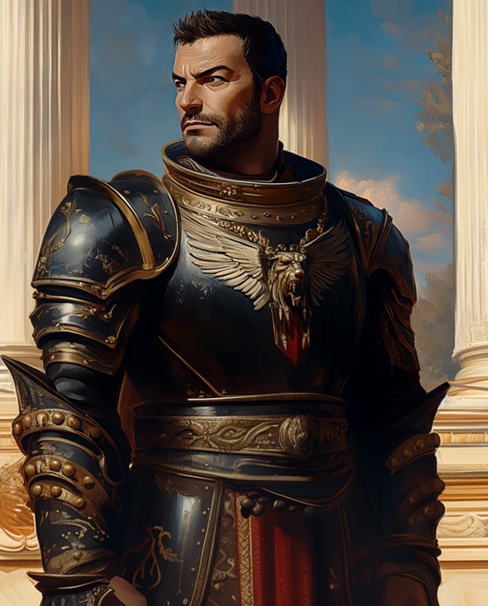

The Peritus Legion is a highly mobile unit of the Grand Army. Made up of what was originally the Rexum’s own unit, the standards to be part of the Legion are high, and combat prowess is the metric. They are typically the first to engage when trouble arises and mobilization of the Grand Army has yet to begin. They are also often used in nontraditional operations that a standard unit would not have the expertise for.

The Peritus Legion is only as effective as it is due to the skills and talents of those a part of it. It is not a first line of defense as they are often mistaken for, but are rather an offensive force that uses speed and tact to often end problems before they get started. The best of the best are who make up the members of the Legion, hosting the most adamant and loyal soldiers.

* **The Arbiter Guard**
* Led by Supreme Justicar Vander Nebzur

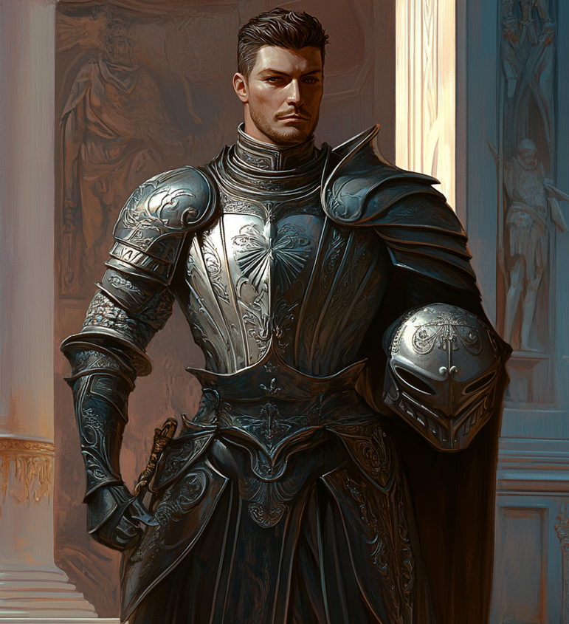

While in times of war a city’s defense relies on members of the Grand Army, for every day peace keeping it is the Arbiter Guard heading the task. They’re not quite a police force however. Arbiters are specifically trained to represent the entire legal system in the Dominion, enforcing the law by acting as detectives, judges, jury, and in some cases, executioners.

The Arbiter Guard are the only wing of the military to have crossover authority and jurisdiction over its other parts. There may only be a handful of actual Arbiters in any given town or city, but for purposes of security, they are in command of all other military personnel below the rank of general who may also be there. While this may sound like a prestigious position, Arbiters are viewed almost universally with disdain from other parts of the military because of this. As a counterbalance to the power they wield, Arbiters typically only take direct command over other soldiers when numbers are needed for specific operations. Otherwise it working through unit captains and giving quite a bit of autonomy to soldiers assigned to guard duties that keeps security operating as smooth as possible.

* **The Obscura**
* Led by Ophani Cassio Beckett

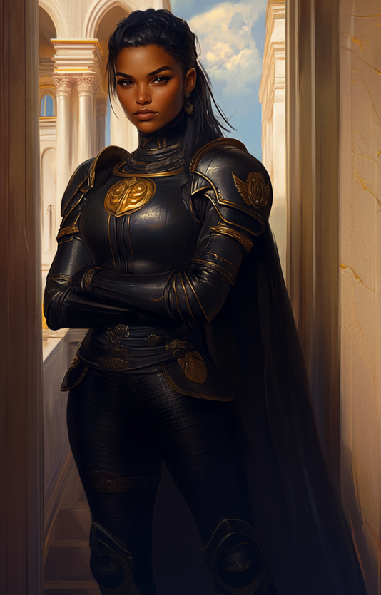

The final wing of the military is the Obscura. As may be alluded to by their name, the Obscura are not every day out in the open soldiers. In fact, most Obscura don’t openly operate as soldiers at all, leading to the vast majority of the military having little to no knowledge of who they are and what they truly do.

The Obscura are spies, deep agents, and often carry out covert operations and assassinations. They also help to maintain order and loyalty within the military as a whole by spying on their fellow soldiers. Whereas the Arbiters Guard may have legal authority over its peers, it is the Obscura who have the dirt.

**Enemies of the Dominion**

* **Liberation League**

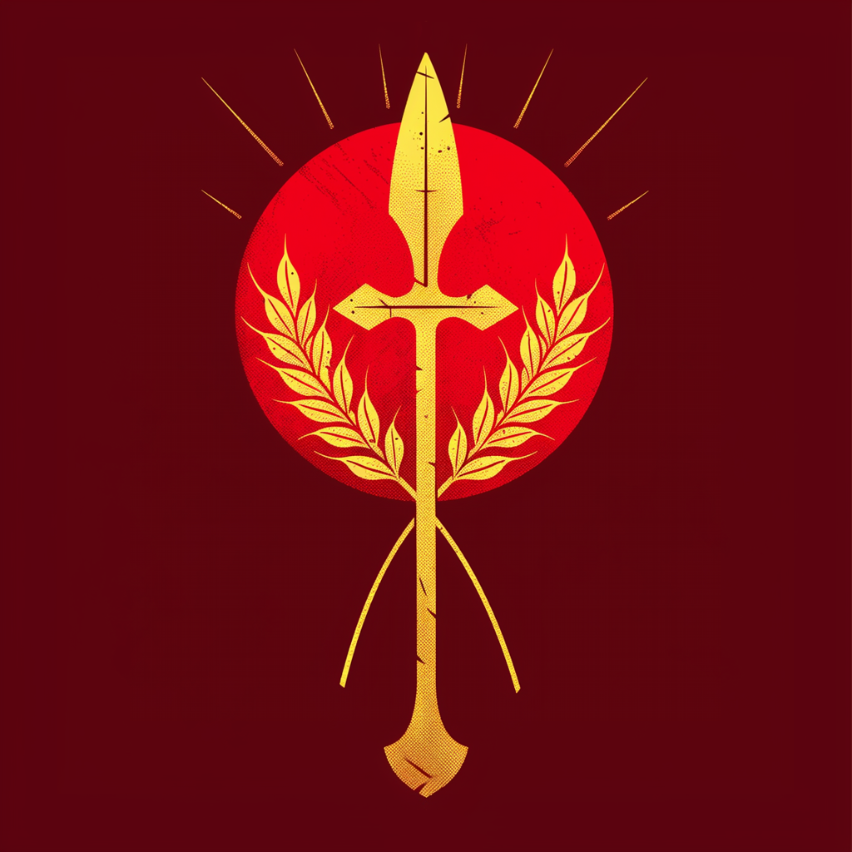

Led by the Avtrekker Triumvirate

The Liberation League’s origins go back as far as the end of the War of Unity. Many noble houses of kingdoms conquered had two choices; bend the knee or face total destruction. What some saw as just a scare tactic quickly learned that the Rexum was not one for lying or deception. The Kingdom of Dodklip found this out, or at least they would have if they weren’t virtually wiped from the continent. Witnessing the absolute scorched earth approach of the Rexum’s conquest brought many nobles to choose service in place of the complete erasure of their lines.

Naturally however, those forced into service, especially those accustomed to being atop the social ladder, did not particularly like losing the status they once held. The Dominion is a meritocracy that rewards skill and feats, not bloodlines. A conspiracy of noble houses had planned on assassinating the Rexum and restoring the feudalism that they had always known. However this was far easier said than done. With the Rexum’s gifts and natural disdain for aristocracy, any attempts at disposing were squashed, and the nobility were always punished, whether they had any relation to the plots or not. Most houses would eventually distance themselves from even consorting with each other out of fear of persecution.

Nearly destroyed, all but two houses remained in cahoots with the original conspiratorial goal still in mind. However, the conspirators went far underground to keep their activities hidden. As decades passed, newer generations separated from their absolute affluence began to fall sympathetic towards commoners, seeing them as being just as mistreated as they were. While far from being comparable, the sentiment at least helped change the group’s goals from simply reobtaining power and influence to now being more aimed at freeing all from tyranny.

With insurgencies being funded through old money and a network of brokers and middlemen, most rebel movements over the last 50 years have been funded through the umbrella of the Liberation League. While it had thus far seen little success, with the death of Karz, multiple groups took the incident as a sign to strike out in full force. While not initially intending to reveal themselves, the fervor and tenacity of this new movement forced various nobles and officials out from the shadows and into becoming the faces of rebellion.

Today the vast majority of rebels have pledged loyalty to the Liberation League, seeing it as the best chance they have at defeating the Dominion. At the head of the League are representatives from the three main facets of the rebel alliance. On behalf of the nobility, a Chancellor was elected as the political leader of the League, a former general of the Dominion was placed in charge of its military forces, and a hero amongst the commoners was elected to ensure the voices of the people are acknowledged when any decisions are made.

* General Theodora Casseri - Advocate for the common folk

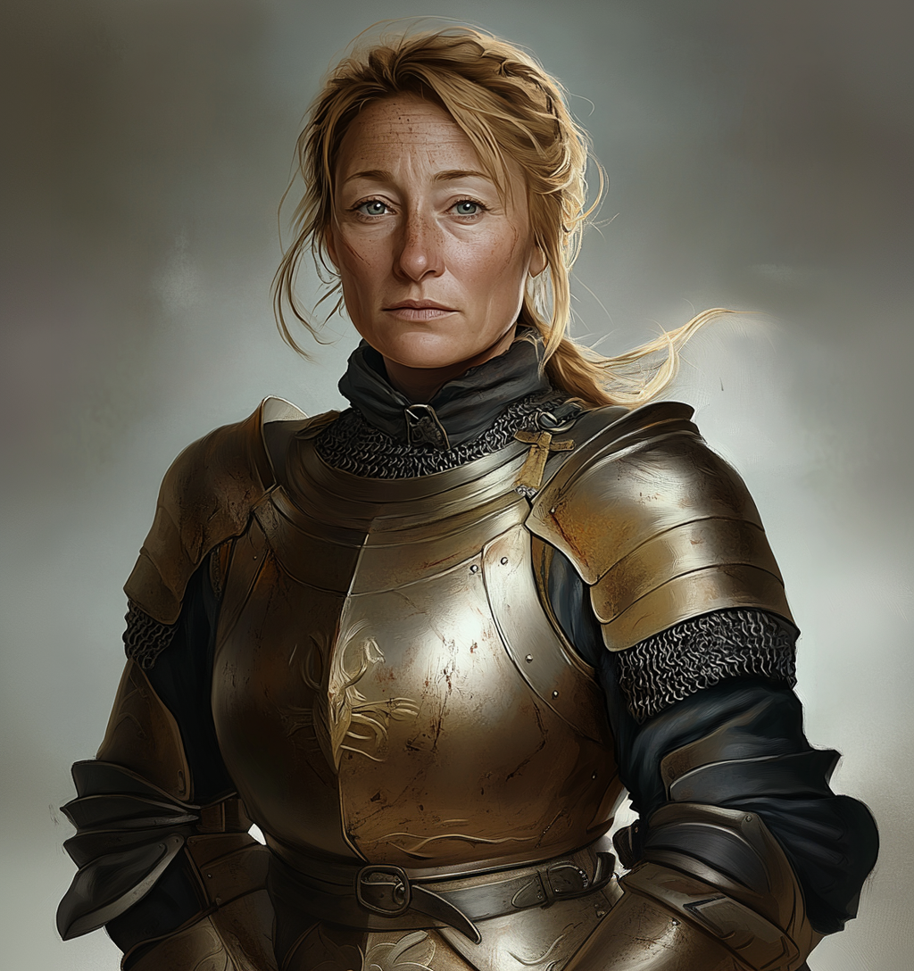

* General Lando Gaisetic - defected Dominion general

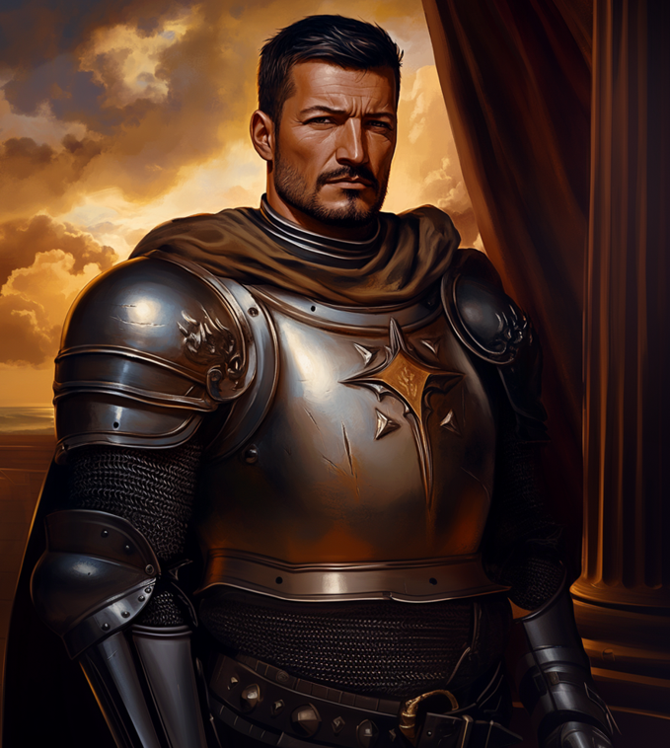

* Chancellor Ansa Modron - representative of noble rebels

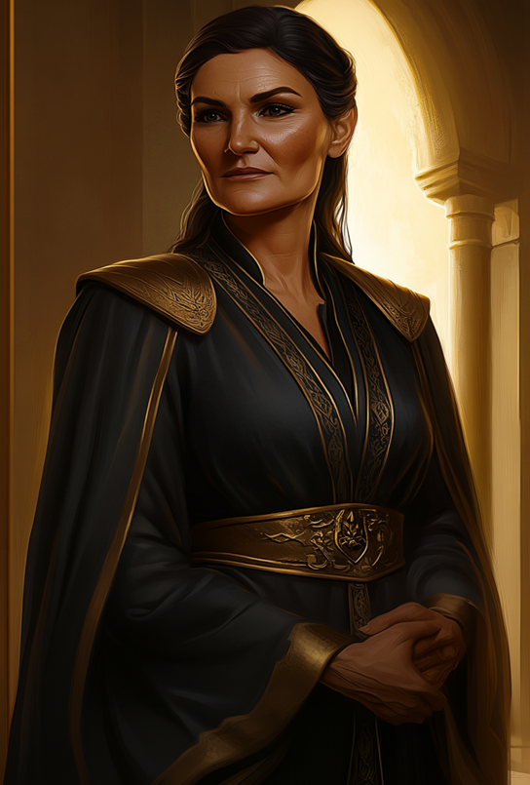

**Southern Regions**

Areas on the fringes of the Dominion were always less inclined to simply follow the rules and laws imposed upon them. With Karz’s death and subsequent weakening of the Rexum themselves, the South Western portions of the continent asserted their independence, having already long been a haven for rebels and insurrectionists.

* T**he Morizen Alliance**

Led by Fo Uldin Kekeg

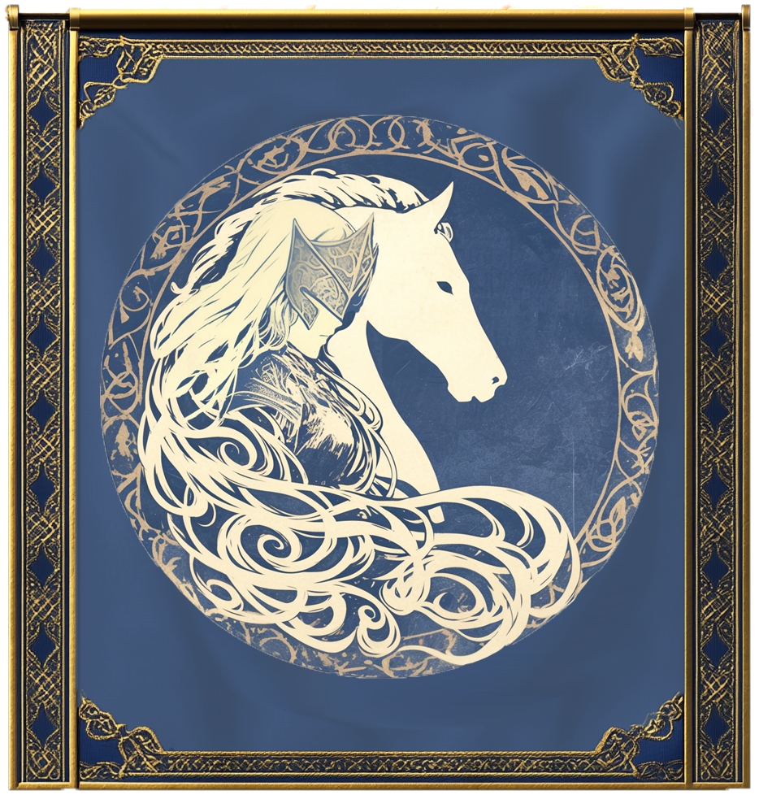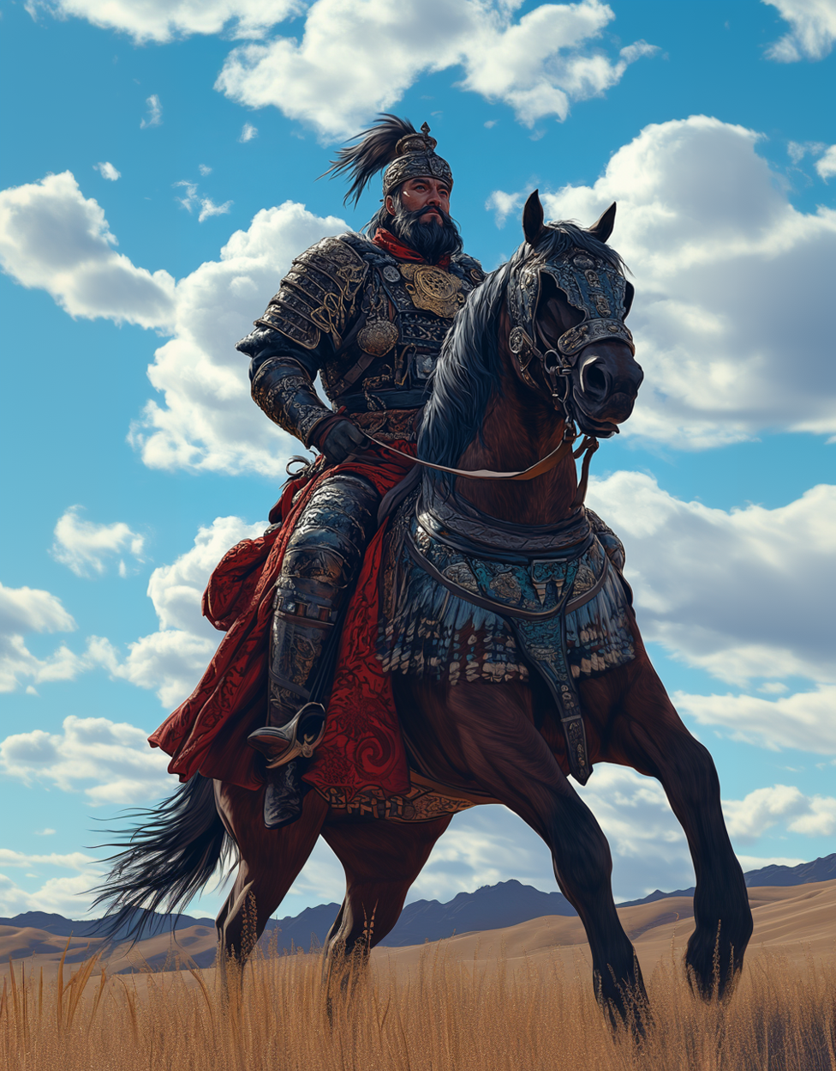

The south of the continent has always been a bit removed from the conflicts of other kingdoms. Natural barriers such as vast ancient forests and jagged mountains have consistently made it difficult for the more central states to maintain any meaningful presence in the region. While the people of the Lourfold planes are viewed as being simplistic and barbarous, they are also recognized as being the most skilled and fearsome horse riders in all of Skidewen.

There is little in the way of organized territory throughout the large grassy plain as the vast majority of its native inhabitants are nomadic peoples. Still, while made up of different clans and tribes that for the most part are quite independent, in times of great strife they’ve been known to quickly organize under a single banner to defend the lands and fight off foreign invaders. When such alliances are formed, the people refer to themselves as “Morizen”, forgoing any previous independent identifiers. A singular leader is chosen via a grand trial by combat to lead the Morizen for as long as the alliance is deemed needed.

With the conclusion of the War of Unity, the lands of Lourfold were not viewed with any particular interests by the Dominion. Comparatively underdeveloped and isolated from other territories, the area would often be ignored. However, outside of their grand alliances, parts of the Morizen have a grand history of riding out into surrounding villages and towns to pillage and raid. Such acts of provocation usually warranted a forceful response from the Dominion, which in turn resulted in the Morizen alliance forming. While it has been a long and arduous cycle of peace, raids, and war, many feel that the Rexum has purposely kept this theater active over the years to give himself a neigh perpetual war to use as his personal playground.

* **Tabenak Confederacy**

Led by Emira Jocelyn Arev

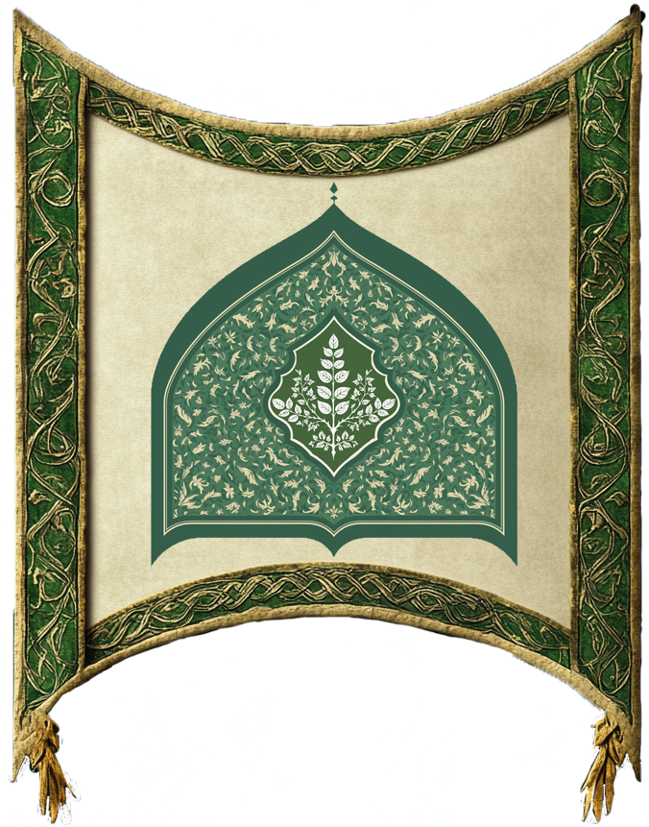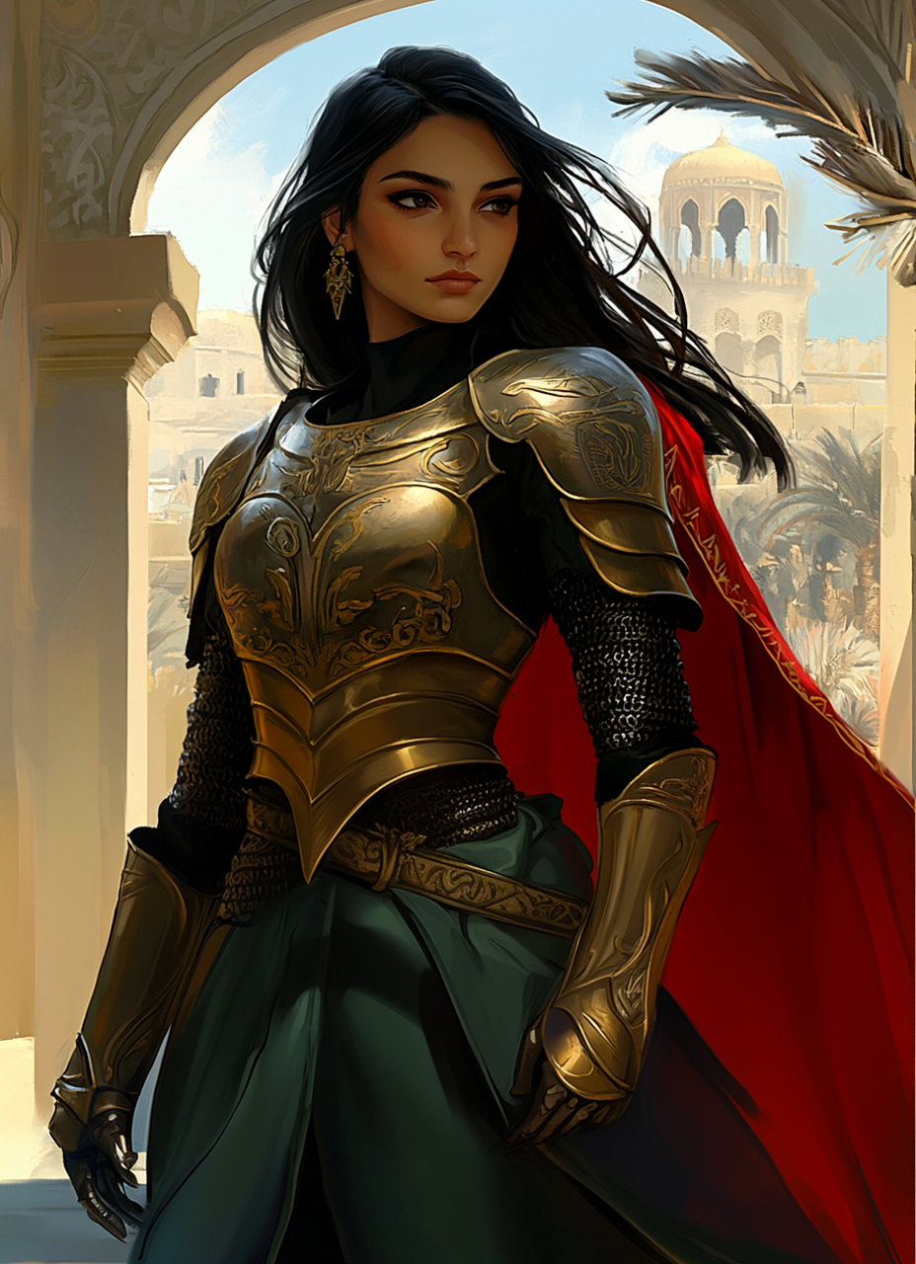

The Tabenak region seems like an entirely different world when compared to most of Skediwen. It is dry, arid, and often experiences high temperatures that have been known to sometimes be deadly to those who travel there. It is also a land with large deposits of gold and unique spices that can be found nowhere else on the continent.

Unlike its neighboring Lourfold, the peoples of Tabenak were far more sedentary in nature. While not as desolate as the desert of Støvland, the environment is still sparse with fresh water, making constant travel more of a detriment for those desiring to do so. Where pockets of paradise were found, people chose to stay and set up agricultural roots. Over time these oases grew in population, developing into large city states. Not exceptions to the nature of mortals, conflicts between rivals was quite common, even during the Divine Age. As legend holds, an emissary of the gods was able to bring lasting peace to the region, at least until the pangs of the Discordant Age finally made its way to Tabenak.

While remote and well separated from the majority of states at the center of the continent, a relic of an age long since passed that was originally its tether to greater Skediwen would prove to later be its chain. Believed to have been built by the Titans of the Dawning Age, a large bridge through the Verdant Mountains connected one of the most isolated parts of Skidwen to its neighbors on the other side. For thousands of years the Grand Walkway was used in the exchange of goods and gold between Tabenak and the central states. However, when the gods decided to leave mortals to guide themselves, the continent was thrown into chaos.

While still a far journey, Tabenak was known by all to be a land of great riches. With the Grand Walkway being a rather safe and direct route to the region, central states eventually began to see it as a grand prize to be won. Having the region under their control would only serve to fill their coffers and fund even greater campaigns in the future. As with everywhere else, war came to Tabenak. While the city states of Tabenak were able to defend themselves, constant war proved too much and the cities saw numerous changes in leadership. Yet, due to its drastically different climate and culture, central powers rarely remained in great numbers to occupy the region. This meant other kingdoms lacked manpower to defend their captured territories when new armies would roll through. For centuries the once illustrious Tabenak region became a land of poverty and crumbling infrastructure.

Towards the end of the Discordant Age, those native to the region began to rise up against the foreign invaders, actually being able to expel all foreign powers at one point. Able to regain a foothold the region formed various alliances and took part in the many wars that had engulfed the continent. Primarily being the defenders, near the start of the War of Unity, allied Tabenak forces decided to cut off the main source of their troubles by dealing with the Grand Walkway. While originally attempting to build walls and forts, the allies eventually settled on just destroying parts of the walkway altogether. The sheer size of the structure however proved to be a much grander task than initially thought. Before any meaningful path could be fully cut off, the future Rexum had arrived and conquered Tabenak.

In an unexpected twist, Tabenak wasn’t fully conquered, but instead it was vassalize and given a greater deal of autonomy than other conquered lands of the Dominion. However, as time moved forward many began to suspect this was another instance of the Rexum purposely creating instability to insight rebellion and war as Tabenak has more so than any other territory been subjected to exorbitant tax and exploitation. It’s no surprise that the region has declared its independence from the Dominion at least once every decade since the end of the War of Unity. It is also no surprise that the region was the first to declare its independence after the death of Karz by the hands of the Rexum.

* **The Invaders “ followers of the Living god”**

In an unprecedented event, people’s not native to Skiedwen have arrived upon its shores. Numbering in the tens of thousands, these foreigners were not peaceful in intention as they immediately began to occupy the southeastern peninsula. While a manageable challenge in the past, the recent events within the Dominion have left it weakened and divided. As such the invaders have been able to make a significant foothold onto the continent, facing little resistance.

The more curious threat is that the invaders have claimed to have brought a “god” with them, only escalating the concern. Whether something similar to the prime deities, or simply a powerful mage, this entity has already been observed displaying strange and grand abilities that have assuredly confirmed this to be a threat.

**Cultists Who Wish to Bring Ruin to Al**l

With the chaos engulfing the continent, the rise of strange and dangerous cults have been meteoric. Heavily suppressed in the past, most of these cults remained highly secretive and hidden due to the many brutal inquisitions carried out by the Orthodoxy. Recent events however have led many towards questioning what they once believed, and lost in terms of identity and faith. Biding their time for years, now is the opportune time for these cults to come out of the shadows and begin spreading like a plague over the weak and vulnerable. With numbers on their side, and their influence growing, these cults seek to strike back at their enemies, while also moving ever closer to their dark and mysterious goals.

*The Gods, their nature, and their roles in the world*

The gods of Skediwen are not like those of other worlds. They are far less invincible, and do not need worship to exist. They exist by way of the Grand Divine, the believed creator deity of this world, and of its gods.

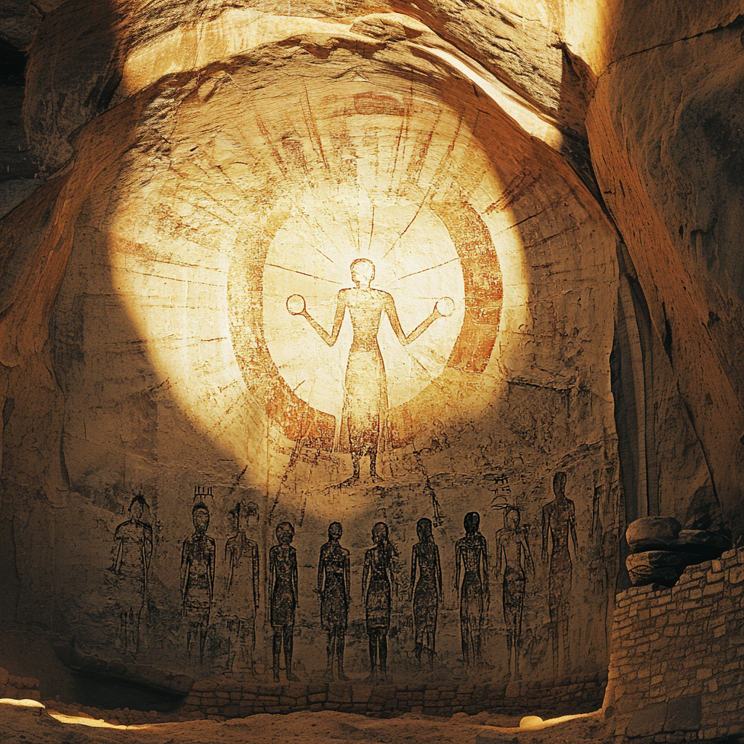

“What a mouse is to a mortal, the mortals are to the gods; yet compared to the Grand Divine, they are but mice.”

-Sage Ikarus Mostannerus

However, the Grand Divine is almost purely mechanical in terms of its purpose, thinking, and actions. It cares not for the plight of mortals. That is not to say that it ignores them, but rather its sole focus seems to be devoted towards keeping its universe as balanced and operational as possible.

To watch over Skediwen, the gods were created to essentially manage and oversee the day to day of the happenings of mortals. The gods are immortal in terms of aging, immune to all diseases, and do not require food, water, or even air to exist. They are immensely sturdy; being impervious to just about any physical method of harm, and are fonts of incredibly powerful magics that no mere mortal could ever hope to muster on their own. Yet, as proved by the Rexum, given the right methods, they are not invincible and can be felled.

The 10 Prime Deities are believed to have been created as blank slates as far back as the Ashen Age, possibly even further for the oldest amongst them. They are featureless at their beginnings, appearing like smoothed over manikins. Overtime, as they observed the world from the “Gylden Hof”, the dimension above the “Pond of Omniscience” just as a baby observes the actions of those around it, slowly learning to do what they do as time moves forward. Unlike a human baby however from the moment they are brought into existence they are filled with a knowledge of everything. Everything except who they are. Overtime as they observed the world through the crystal clear water of the pond they begin to form their own thoughts and personalities, and eventually attaching themselves to different domains within the eather not yet claimed by their siblings. As they harness power from these aspects, the energy melds with the godling to the point of singularity, becoming the idea, concept, or thing incarnate. Now fully self aware, the god becomes a champion of their domain(s), engaging in duties associated with them indefinitely moving forward.

While not every domain has a direct connection to mortals, all the gods are motivated to involve themselves with mortals based on an instinctual belief it helps to fulfill their creator’s prime directive of maintaining the world’s balance. Mortals are bringers of change, and often those changes, if not managed or regulated properly, can lead to disruption of the natural order. Still, they too are creations of the Grand Divine, which means they serve some purpose in its grand scheme. For what other reason would they exist? A question they ultimately do not have an answer for as none truly knows what the Grand Divine wants. This has led to the gods developing differing views and philosophies over their existences, philosophies that would later trickle down to their followers. Despite their disagreements or rivalries the 10 9 prime deities are ultimately all on the same “team”, if one were to think of things in those terms. No god desires to destroy another god.

A loose but binding agreement between most of the prime deities currently prevents them from getting directly involved in mortal affairs. This however does not prevent them from interacting with mortals on individual levels. The purpose of the agreement was to prevent a deity from shaping mortal civilizations beyond what their intrinsic capabilities are meant to allow. As such a god cannot simply destroy tyrants or burn down kingdoms because the cascading effects of such actions more often than not result in creating more chaos . Maybe a bit of a loophole has allowed the gods some degree of leniency towards each other as long as whatever action performed falls into one of their domains. they are able to influence that to then provide some sort of result to the person on the other end.

The gods often walk amongst mortals, though it is almost never out in the open. Through their divine essence and connection to certain domains they are able to provide mortals with aid, be it as minute as a subtle influence towards what falls within their domain, to sometimes physically appearing before a mortal (often disguised in some way to hide their true visages) and offering direct assistance of some kind.

**Civil gods:**

Of the prime deities, the “civil gods” are referred to as such due to their inclination towards order and maintaining a certain status quo. They tend to put their focus more directly in the affairs of mortals, trying to guide them like a shepherd would a flock of sheep. For the civil gods, mortals are viewed as being natural tides of order as they are builders of civilizations. Their self awareness is also interpreted as a gift from the grand divine so that these creatures could comprehend their existence and be able to express their gratitude in ways that most other lifeforms cannot.

* Etifa: Love (romantic, platonic, familial), passion, expression, joy, life.

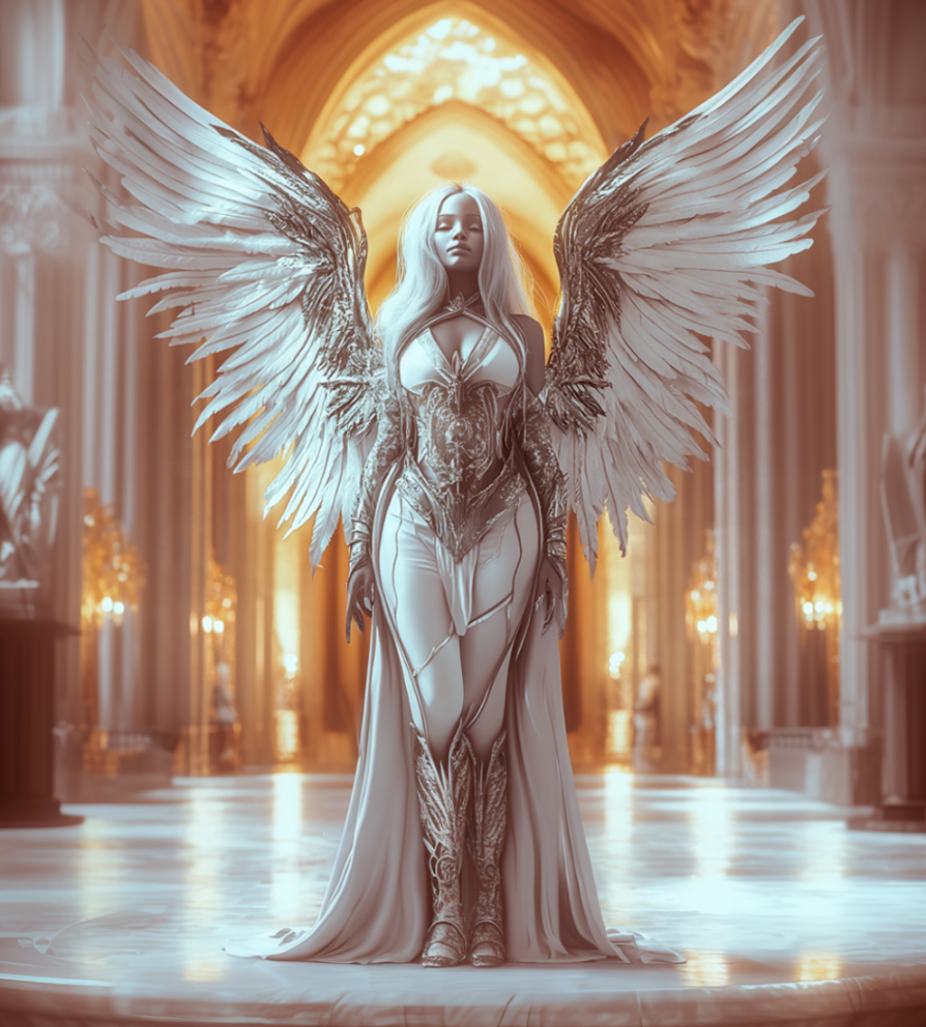

While one would think that love is a force that can be chaotic and overwhelming, it is an emotion unique to sapient life. Etifa is counted amongst the civil gods as most forms of love require community and bonding. While it can lead to destruction, it is far more a force that binds people and brings them together. She is a goddess that works towards bringing mortals joy and is almost universally seen as a symbol of pure good.

Etifa has a particular fondness of appearing as a mortal to walk amongst them, a friendly stranger, inspiring some to overcome their anxieties, and bringing clarity to those whose emotions have either been suppressed or are running wild.

* Karz (deceased): War, conquest, protection from violence, strength, fury, honor

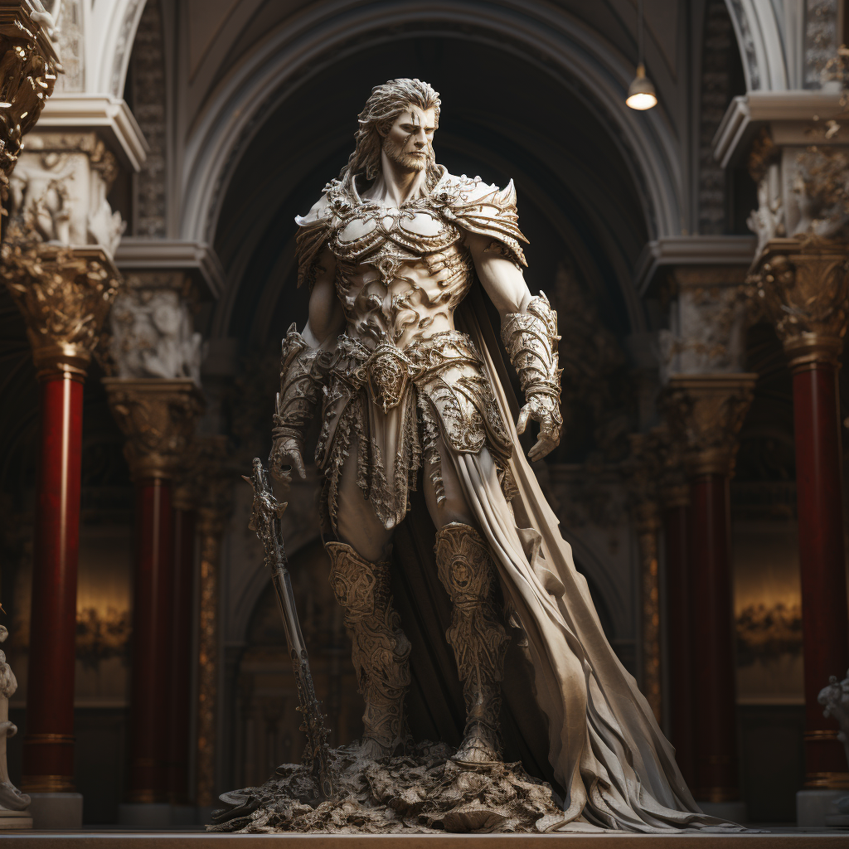

Karz was often believed to be a force for good, despite his nature association to perhaps one of the greatest of mortals tragedies; war. It is said that Karz undertook the mantle of a war god in order to ensure there was some degree of order in what is otherwise a chaotic happenstance. With the inevitability of war upon Skeidwen, Karz’s blessing was sought to protect those who were forced to fight, those who fought because of duty, and ultimately, to bring about peace via a successful campaign.

The nature of Karz’s death is one of mystery as he is to date the only god ever known to have been slain. Though, there is no solid agreement between theologians and scholars if Karz is truly dead, or if his defeat at the hands of the Rexum simply severed Karz from this plane. After all, does a god have a soul? If so, what happens to that after death?

The blood of Karz was described as a thick and glittering golden liquid. The liquid, as well as the body itself, sank into the ground as if it were being put through a sieve, the body disappearing completely within 5 minutes.. From that spot sprouted a tree that continues to grow from that spot at a rapid rate of at least 2 feet per week. Attempts to cut the tree down have all been in vain as its bark appear to instantly return to form each time parts are removed. Amongst the devout there is belief that Karz is this tree, and that from it, he will be reborn anew. However, others see this tree as perhaps just typical plant growth that happened to be given extra potential by absorbing the essence of a deity’s blood. Not caring what of the true nature of this tree is, the Rexum totes as a monument to his power.

* Zarunok: Authority, law, order, dominance, power, hearth fire

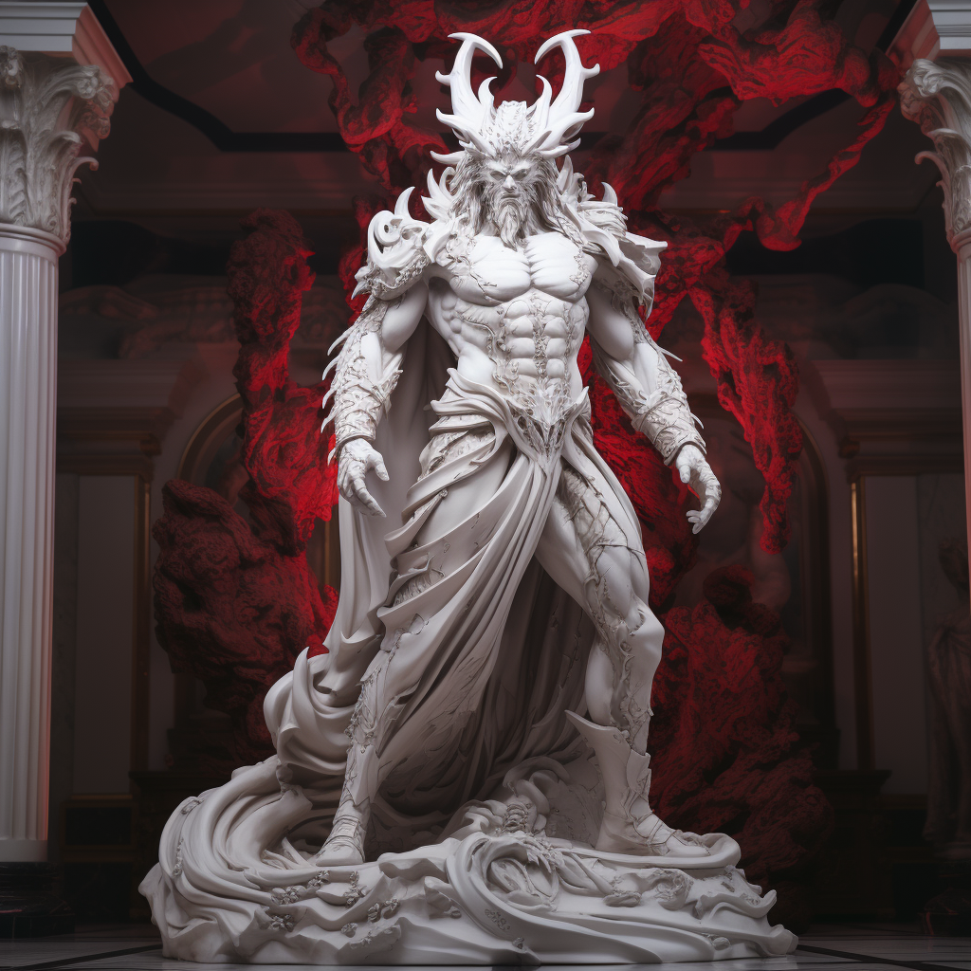

Despite his fiendish appearance, Zarunok is not seen by most as “evil”. Rather, he is commonly viewed as a necessity of society. Without a centralized figure providing command, projecting authority, and establishing laws, a society cannot exist. Often times there may be decisions that have no great answer, but as is the same with Zarunok, being viewed as the villain is but a small price to pay for the continuation of civilization. Some believe that the devils of the hells stylized themselves after Zarunok and hold him in high esteem, whereas others believe Zarunok to be their progenitor.

* Cirrepeti: Pain, torture, blood, binding, punishment, obedience

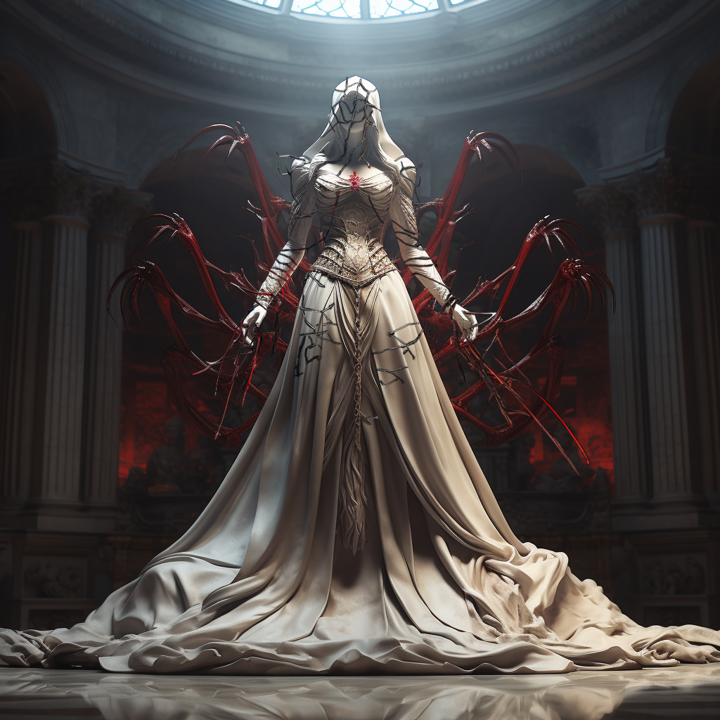

A rather strange god, and one that elicits fear more than anything else, Cirrepeti is believed by most to be the youngest of the prime deities, only having made themselves known in the last century or so. They oversee domains that are often thought to be leftover from what others had already taken. As such, Cirrepeti is viewed as more of a consequence than an active force themselves. They are perceived as an emotionless being, contributing to the theory that all the gods started as blank slates, and is often seen in tandem with other gods executing their wills. As such, Cirrepeti is not widely worshiped themselves, aside from small fringe groups who believe that only through personal suffering can one actually interpret Cirrepeti’s will. It is believed that connecting with them brings one closer to the Grand Divine themselves, who perhaps ironically, is thought to be most similar to the youngest god as they have been the least influenced by the mortal world.

* Foshorey: Protection, justice, victory

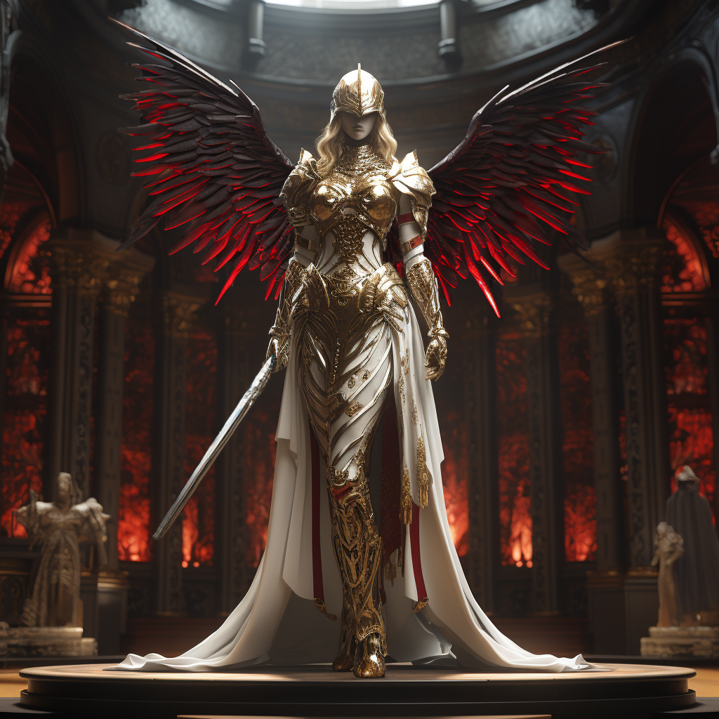

Foshorey is similar in many ways to Cirrepeti in that they are considered to hold domains of consequence rather than concepts and phenomena. However, Foshorey is not seen so much as blank slate as she does play an active role from time to time. She is considered the second youngest of the prime gods, and is theorized to be in the formative stage all the gods went through before they obtained the personas they have today. She represents justice, which can be seen as a consequence of law and order, but the type of justice delivered to those who invoke her name do not necessarily fall within what laws may dictate. While this could lead her to being associated with the “Wild” gods, it still seems that for the most part, Foshorey upholds tenets of society, even if they do not always do so in the predictable way.

With the death of Karz, some believe that Foshorey has, or will take over his domains as there are many connections to the ones she currently holds. As such, some have already begun to invoke her name in their prayers in that regard.

**Wild gods:**

Contrary to the gods associated with order, the “wild” gods are much closer to aspects of freedom, and independence. They are not as focused on the plight of mortals, but rather, they look towards the wider balance of the natural world, with mortals being seen as just part of it, and not its center.

* Caserrah: Nature, forests, beasts, fey, survival, instinct

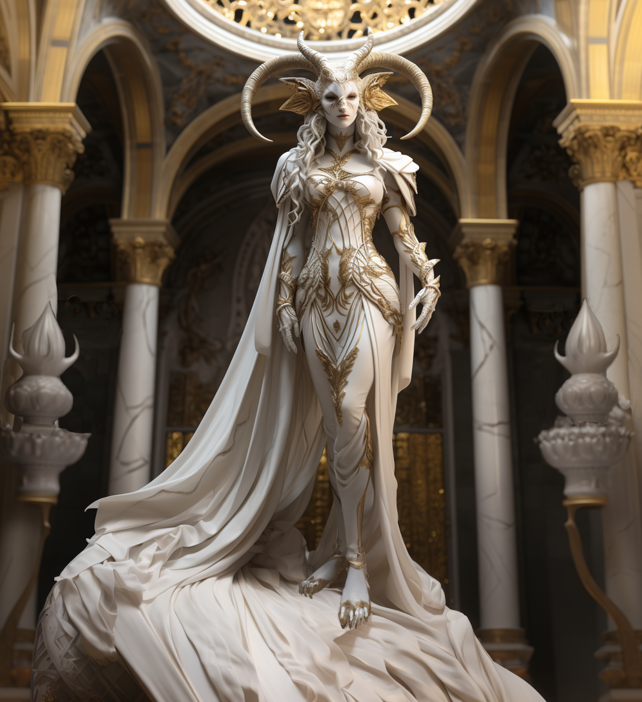

Caserrah is the goddess of the wilds, and represents the environment as a whole. She is deeply tied to what is called the “natural order”, which is to say the all things outside of mortal society. While she upholds a certain type of order, that order in itself is one that is nearly antithetical to that of what is foundational to society. Because of this, Caserrah is worshiped like all the gods are, but she is often seen as uncaring and aloof by most mortals. Though on the contrary, for those who do not live in towns and cities, she is very often viewed with much more respect. To these folk she is a preserver of the cycle of life, and aids and protects those who set foot in her domain. However, she expects those who do come to her domain to have some competency, which is where many confuse her with being an uncaring deity. Survival is viewed as a constant fight out in nature. If one intends to enter it, one must have some preparedness, as it cannot be the responsibility for Caserrah to help those who cannot help themselves to at least some degree. Survival of the fittest is what keeps the natural order in order.

In addition to her reverence by druids and outlanders, the fey also hold Caserrah in high regard as their existence overlaps with nature itself. Some amongst the fey believe that Caserrah is on par with the Grand Divine and hold her as their supreme deity. She is believed by many to be in fact the creator of the fey themselves, though this belief conflicts with the known timeline of history.

* Magnafitis: Bodies of water, storms, ice, monsters

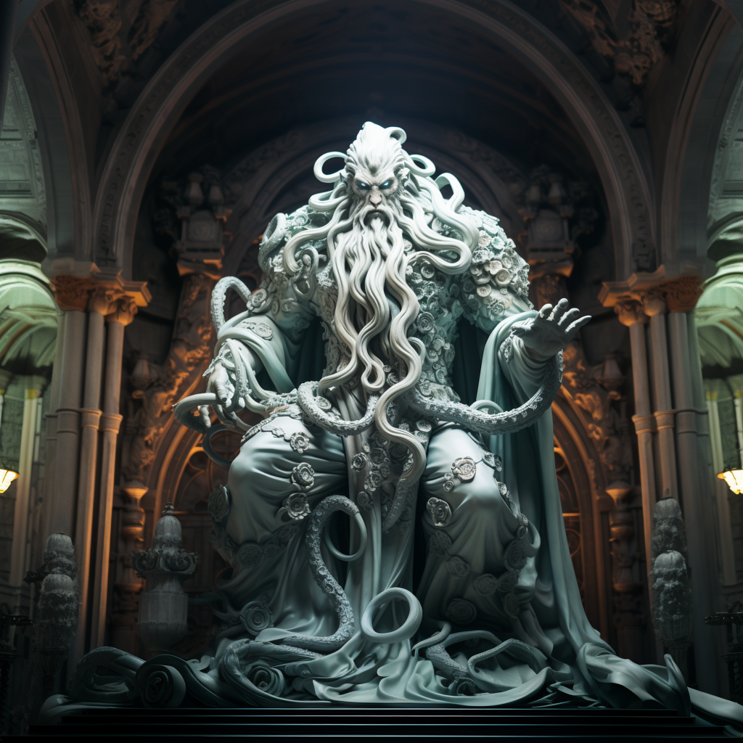

Magnafitis holds domain over the ocean, rivers, streams, ponds, lakes, and so forth. Similar to Caserrah, Magnafitis can be seen as her counterpart with the aquatic aspects of nature. Though while Caserrah’s nature could be described as capricious, Magnafitis is almost universally seen as fickle and temperamental. Magnafitis sees his domain over water as it belonging to him and him alone. It is common practice for those visiting any large body of water to ask for approval first by way of a prayer, or risk upsetting the god and recurving those who enter, must do so with his approval (via a prayer) or experience some sort of torment caused by his hand.

Most creatures not viewed as “natural” are believed by many to be creations brought into existence by Magnafitis. Such creatures are just one of the many ways to punish mortals for some offense believed to have been inflicted upon him.

Magnafitis, while certainly not viewed favorably by most, does still have his supporters. Being perhaps the deity which demands the most respect, those who go out of their way to garner his favor generally see calmer waters and greater fishing catches. As for those forms of life that originate in his domains, such as merfolk, they are treated with much more patience and agreeability than landwellers.

* Detarch: Wisdom, freedom, trickery, deceit, luck

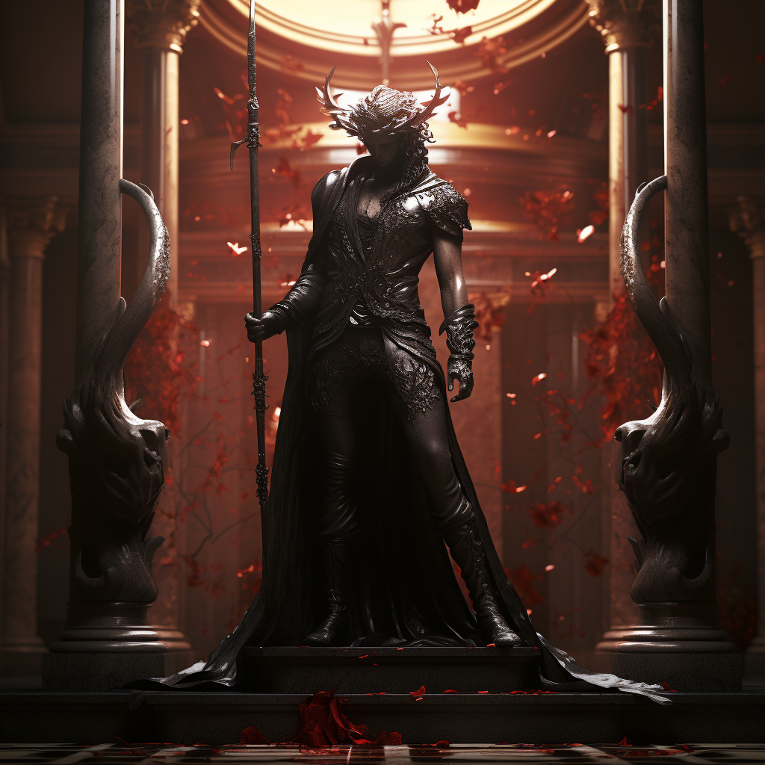

Detarch is a favorite amongst those who see themselves as being under the service of another. They are a god that is the embodiment of overcoming adversity, despite being seen as weaker than their opponent. For what they may lack in terms of strengths that the other gods possess, Detarch often uses their wits to best others. In myth, Magnafitis is often placed in an adversarial role towards mortals, whereas it is often Detarch who intervenes on behalf of the mortals, saving them in some (often convoluted) manner.

Detarch is often counted amongst the most benevolent of the gods as their existence is almost entirely centered around aiding less fortunate mortals to some degree, and punishing (often via humiliation) those who abuse others.

While it could be argued that they do not quite align with the ambivalence the other wild gods share, their disregard for authority naturally puts them in contrast to where the civil gods stand.

**Neutral gods:**

* Xchimaltia: Death, the stars, night, darkness, smoke, prophecy

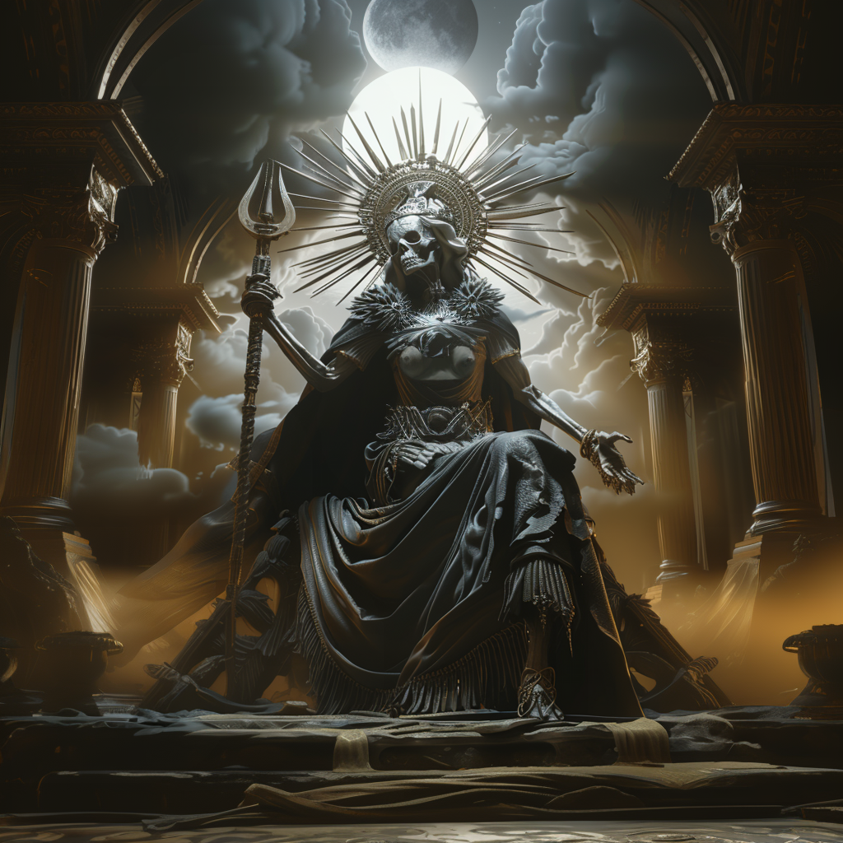

Of all the prime deities, none are viewed with more reverence than the sovereign queen of death herself. Her influence touches all, even the gods, as many believe was Karz’s fate. She is sometimes referred to as “the first” as it is believed she was the first deity created by the Grand Divine.

Xchimaltia is sometimes grouped with the civil gods primarily as the afterlife is seen as being entirely under her control. Death is an inevitability, and because of this, there is no stronger law of the universe than that from darkness sparks life, and to darkness all will return. However, along with her twin sister Osanda, they fall into their own category as being neutral. Neither abide by the agreement of non involvement in mortal affairs. While orderly Xchimaltia was not present during the civil gods artifact retrieval incident, though it could be argued that she did make an appearance.

Unlike deities of other pantheons, Necromancy is not viewed as an affront to Xchimaltia as it may be to them. To embrace undeath brings oneself into the domain of Xchimaltia, while simultaneously existing amongst the living. It is perhaps the most direct representation of Memento Mori, something that the goddess finds delight in reminding mortals of. Creatures of undeath can truly die, be it from rot, or from destruction. Any extension to what would be an eternity otherwise is not concerning for one who has an eternity to wait. However, where mortal arrogance can bring ire is when they attempt or believe they can stave off death permanently. No matter who they may be, none can truly escape her.

Many believe the stars in the sky are the souls of the departed, beacons unto the living, forever swimming in a great pool darkness. Xchimaltia sits upon a marble throne on the moon as she places each new soul in its spot in the night sky. Views differ from what exactly happens to one who dies, but most prefer to think this fate to be one bliss opposed to the pessimistic view that eternity after is spent alone in darkness.

* Osanda: Chaos, destruction, violence, terror, renewal, void

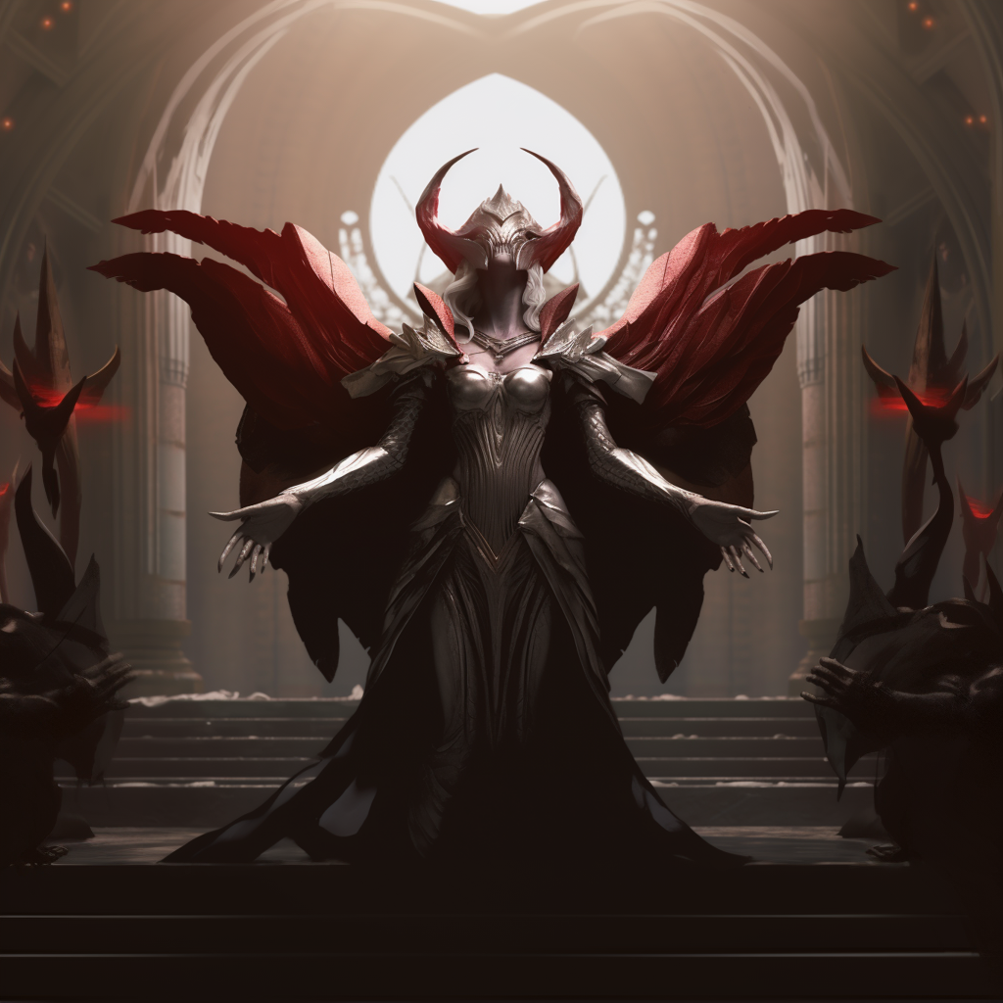

Osanda is theorized to be the oldest of the prime deities, just after Xchimaltia. They are commonly seen as “twins” as not long after death entered the world, the fear of it came immediately after.

In many ways she is antithetical to the other gods as unlike them, Osanda is not really worshiped. Prayer towards her are not for blessing or aid, rather, prayers to Osanda are believed to ward her away and prevent terrible things from happening. Even those in the past who have attempted to pray for the destruction of their enemies by way of Osanda only ended up attracting her fury upon them.

Interestingly, despite holding chaos and destruction as her prime tenets, she is also of the domain of renewal. She is viewed as a necessity as for something new to grow, it often means something old must die. Much as a forest fire brings chaos and destruction, from the ashes grows new life; fed by the nutrients of the burned remains.

As with her twin, Osanda does not abide by the agreement of not directly involving herself in mortal affairs. Just as with Ximaltia, her domains extend far beyond what the others hold. She is a part of what makes existence what it is. As chaotic in nature she may be, it is in equilibrium with all else.

**Other “gods”:**

While the 9 prime deities and the Grand Divine are the most well established and worshiped in Skediwen, they are not the only entities to be considered gods, or at least in terms of power, on their same level. These other entities can be referred to as “gods”, but they are either foreign to Skediwen (originating somewhere beyond the continent), or are considered to be some supernatural force with powers similar to that of a god, but have no relation to the prime deities and who have unknown motives. The worship/knowledge of these entities is sparse in Skediwen, and in most cases, their worship is considered heretical to the official religion of the continent. While they may hold similar domains to the prime deities, it is unknown if that is possible (more than one god holding dominion over a specific domain), or if they are more the personified manifestation of a domain that is independent from the corresponding god’s influence/control.

* The Living God: Unknown, believed by their followers to represent peace, mercy, unity, and “cure”

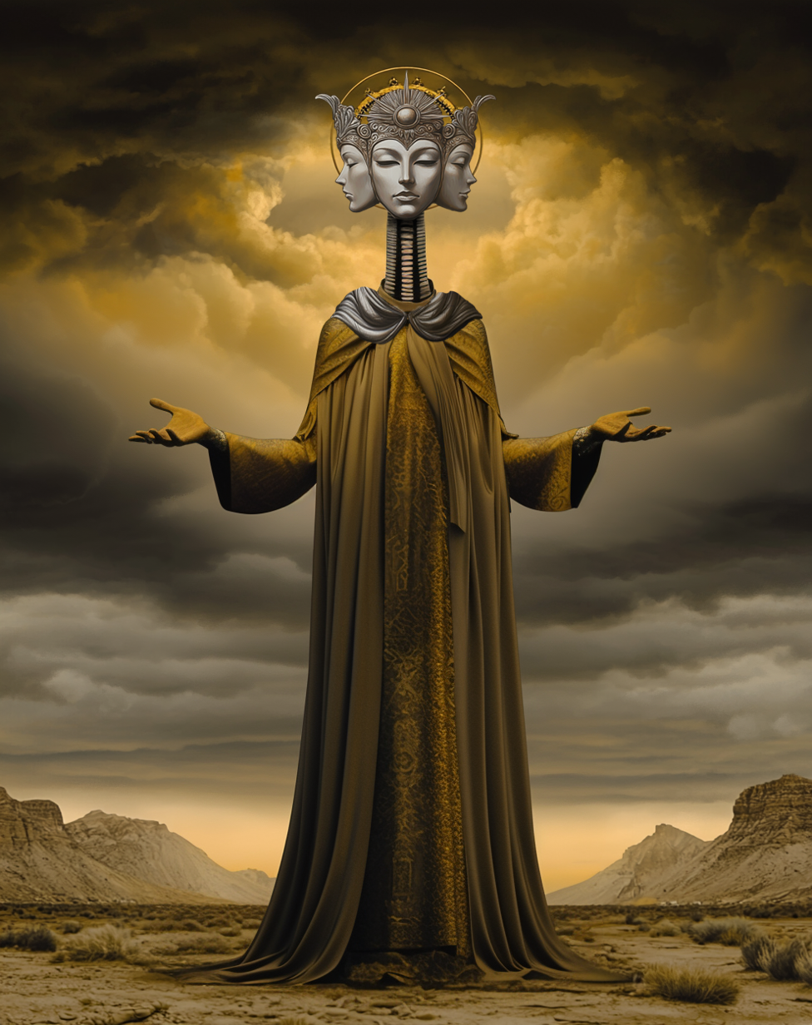

Perhaps the most well known, and most debated “divine” entity is that of the one whose influence has been rapidly growing on the continent, Known simply as, “The Living God” they have arrived in Skediwen fairly recently from parts unknown across the seas with thousands of followers in tow. Many of these followers are unlike any of the mortal beings found in Skediwen as they appear much closer to beasts than people. However, amongst the ranks of these followers are some mortals, who aside from different forms of dress, are indeed part of the same species as those of the continent.

It is clear from their actions the foreign visitors are invaders as they’ve overtaken numerous settlements which had been part of the Rexum’s Dominion. Intal received via captured individuals exclaims that the “Living God ''and their followers intend on conquering and converting all of Skediwen. Disturbingly, the beast-folk counted amongst the Living God’s retinue were in fact people at one point. transformed by the supposed deity as part of their “conversion”. These creatures are completely loyal to the Living God and serve their will with no hesitation or fear of harm.

The entity itself is believed to hold some great degree of power as seen by their abilities to transform and retain control over such a large number of beastmen. But many within Skediwen are not quite convinced that this entity is truly a god. Be it ingrained beliefs or ignorance of the wider world, this entity is something most in the continent have never faced before.

Information within occupied territories is scarce as the towns and cities that were captured have been locked down and cut off from trade and travel. In what little information that has been able to make it out of, the Living God themselves have exclaimed their presence in Skediwen is to free mortals from their pain, misery, sorrow, anger, and agony and to bring about an age of everlasting peace and unity.

According to non transformed followers, the moniker of “Living God” is meant to represent the entity’s humility by walking and living amongst mortals. They don’t hold themselves to be above mortals either, but rather they see themselves as a Shepherd, guiding and protecting their flock, while also bringing the wayward “back home”.

* The Devourer: Ceaseless hunger, destruction

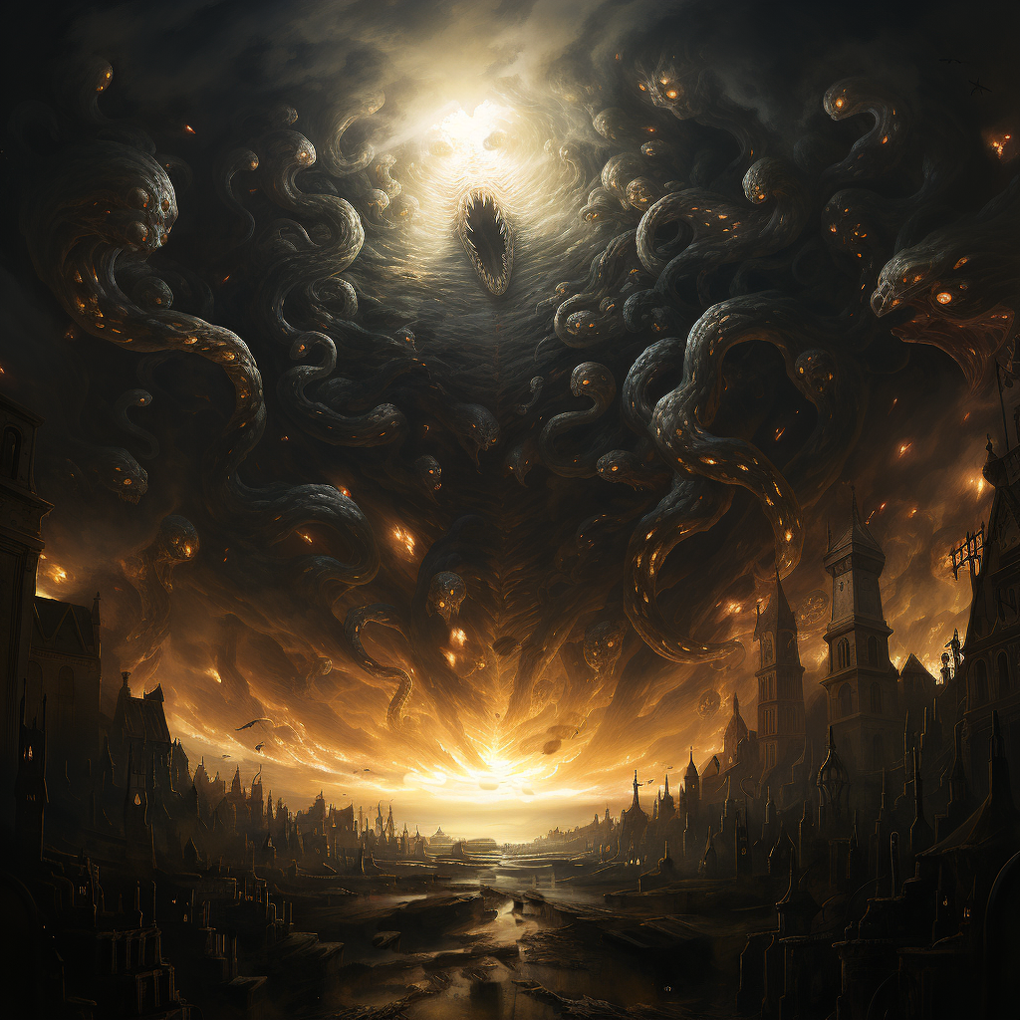

Known to few, but mentioned in some of the oldest of ancient texts, the entity known simply as “The Devourer” is believed to be a competing force equal to, if not greater than that of the Grand Divine. Whereas the Grand Divine is viewed as the creator of all, the Devourer is believed to be what shall end the universe as we know it.

Much about the Devourer is unknown as what little information exists only provides but a glimpse into the nature of this entity. It is said that it has a never ending and insatiable appetite which drives its existence towards devouring anything and everything in sight. One prophecy in particular tells of this entity existing prior to the Grand Divine’s creation of the world. Given the chance, the Devourer seeks to consume the lands, the gods, and even the Grand Divine themselves.

Believed to have been sealed away by the Grand Divine long before the world existed, it is thought that the Grand Divine’s craving for balance is tied to keeping the Devourer at bay. Should the order of the world be brought into a great imbalance, the seals holding back the Devourer will break, releasing it to fulfill its true purpose.

A very small and obscure network of cults worships the Devourer and hopes to free it as they believe that within the Devourer itself is an entirely new universe. They hold that this universe has been purified by action of it being digested and stripped of its impurities, leaving what is essentially a Heaven-like paradise.

* Xi’Talla, the Apex Queen: Plagues (specifically insects), evolution, perfection, corruption of the mind, obsession, and extinction

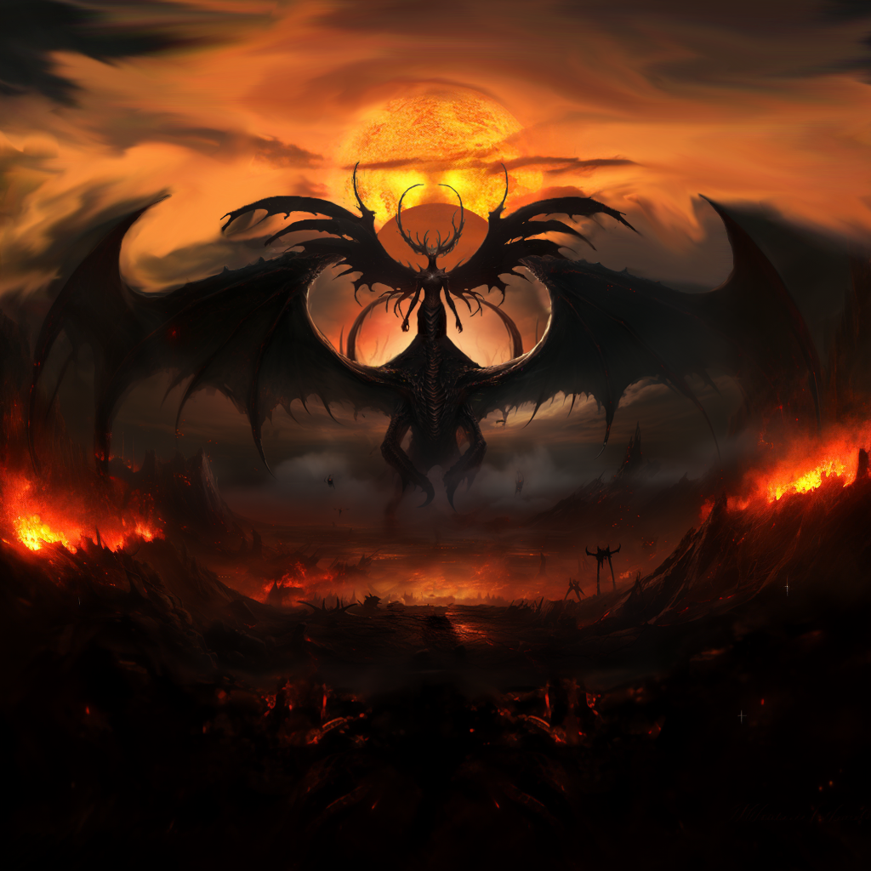

Xi’Talla is an entity known by many names, but to all who know of them, they’re always proceeded by the moniker of the “Apex Queen”. A being of primordial chaos, slumbering deep beneath the soil, they’ve taken shape over millennia, forming a body the size of a city. But while many know of her form, and roughly her appearance, no one has ever laid eyes upon her before. Those who know of this entity have only seen them in their dreams. For while Xi’Talla’s body slumbers, her mind does not. Their presence and influence seeps into the minds of those with curiosity of her existence, slowly corrupting them, drawing them ever deeper into madness.

They are an entity viewed as highly heretical to the faith of Skediwen, and its followers have been persecuted since their cults first started to gain notoriety over two centuries ago. Followers of this cult are very secretive, and when discovered and/or captured, they are often incapable of communicating coherently, be it through religious zeal, or through much more disturbing means. What little has been gained is the result of many years of inquisitions, torture, and piecing together different accounts like a puzzle mixed with pieces that attach to nothing.

From what has been confirmed, to their worshipers the entity is said to be beyond the power of the Grand Divine. It is not a god, but it is also seen as a creator of balance, but represents something totally alien to existing mortal life. To understand it, what it wants, followers offer their minds and bodies to Xi’Talla, losing themselves to madness and grotesque mutation. Xi’Talla is a force of nature, the tide of time, that will remove all the mortal species, their gods, the current flora and fauna from the planet and create a brand new world from the corpses of the fallen, one that will only be inhabited by their brood.

As far as Xi’Talla origin, it has either been something that has existed since the dawn of time, is a being from a different dimension, or is the consciousness of the planet itself. Again, separating what is dogma and what are misdirections is no easy task. Some even conflate Xi’Talla with the Devourer, though either cult vehemently deny the entities to be one and the same. While both seek total destruction, Xi’Talla’s purpose is not total annihilation, but to create a new world atop the ashes of the old.

To know of Xi’Talla is to involuntarily invite them into your mind. That is not to say one is doomed to become an adherent by simply knowing what Xi’Talla is or wants. But a poison always has a source, and those who continually dwell on the subject, the more poison they absorb. Many an inquisitor attempting to learn more about Xi’Talla’s cults have wound up being indoctrinated themselves.

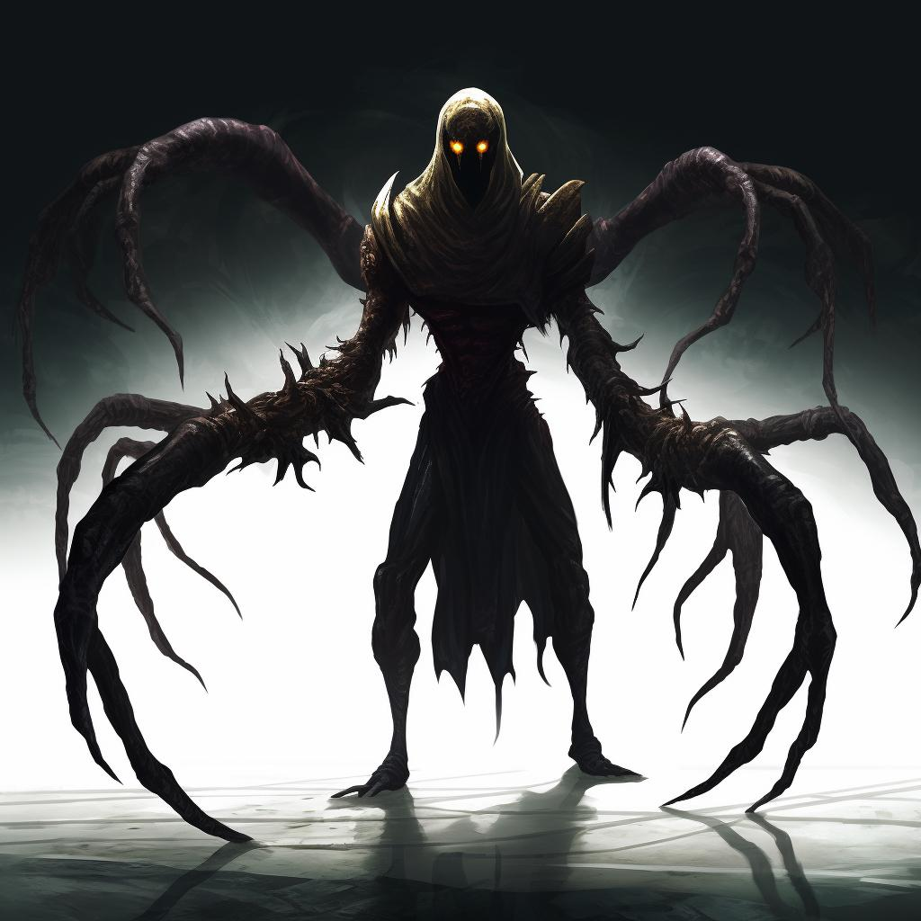

* St. Imelda: Protection, healing, duty, resistance, zeal

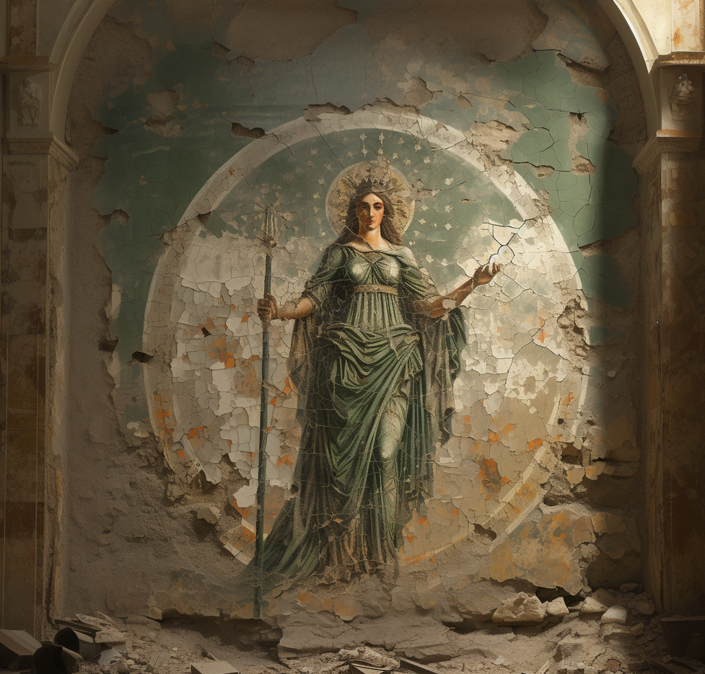

St. Imelda is a popular folk hero in the southwestern lands of Skediwen. Over a millenia ago, long before the Rexum’s war of unification, a conflict between two small southwestern nations developed into a long and bloody war that dragged every other nation across the southlands into the conflict. For over a decade, the war raged on, killing hundreds of thousands caught up in the turmoil, with no end to the chaos in sight. That is until the day a mortal ascended beyond their mortality.

As the legend goes, during what had been the largest battle thus far, one soldier, a woman named Imelda, appeared in the middle of the roaring battlefield wielding a golden shining spear. She had claimed to be chosen by the “highest” amongst the deities to voice their demand that the war end. Confusion spread amongst the soldiers as the woman spoke softly, yet all were still able to hear as if she were less than an arms length away. Some had stopped their fighting out of curiosity and astonishment. , But not all were convinced. After the brief pause the majority of soldiers resumed fighting. One soldier in particular saw Imelda and thought her to be an enemy and rushed to run her through, however, In a flash, she had pierced through him with her spear. Seeing their comrade fall, others began to advance on her, only to be dispatched the same way at speeds so fast the eyes could follow. .

Seeing her words being largely ignored, she made another soft spoken decree that rang out louder to every soldier on the battlefield.

“I tellith the truth! Those who stand against my decrees stand against the gods themselves!”

For those loyal to the gods, she demanded they fight alongside her, no matter which army they belonged to. As for the nonbelievers, they had their choice to fight her or run. What began next was a spectacular display of fighting prowess in which this one woman was fighting tens of soldiers at a time, eliminating each of them with ease. Witnessing this invincible fighter anointed by the gods the battlefield quickly morphed from two opposing factions fighting each other, to a now growing battle between Imelda new forces, and everyone else. The ensuing fight would not last long as just minutes later the last opponent fell, and the final combatant defecting to join Imelda.

Imelda continued to lead her quickly growing forces into a handful of battles, repeating her the successes in each one. As she marched, she was known to aid areas affected by the war by healing the injured, and using her recruits to aid with repairs for as long as they remained stationary. Less than three months after her first battle, the war was over and peace had returned to the region. The tales and exploits of “ Imelda The Great” were spread far and wide throughout the Southlands. As to the aftermath, when the final peace treaties were signed, Imelda had declared her mission was completed and she laid her spear and helmet down by her feet. Seconds later a beam of light from the heavens descended upon her and she began to fly up into the sky. As she departed, many swore she grew angelic wings before disappearing from sight, melding into the blue sky itself.

The legend of Imelda would inspire many for centuries, so much so that many began to invoke her name when dealing with difficult situations. Many would claim that when they had done this, miracles would happen, much in the same manner as healers known to have a deep connection with the gods. Because of this, peoples of the region began to actively worship Imelda as if she herself was a god.

To date, the worship of St. Imelda is almost entirely localized to the southwestern portions of the continent. While the official Orthodoxy does not recognize St. Imelda as a god, her worship is not ostensibly outlawed. However, due to the region being commonly in revolt, and with St. Imelda often being invoked as a rallying symbol for the peoples of this region, many churches and temples featuring or devoted to her have been destroyed, as well as her worshipers being imprisoned and persecuted.

* Yaluska of the Mire

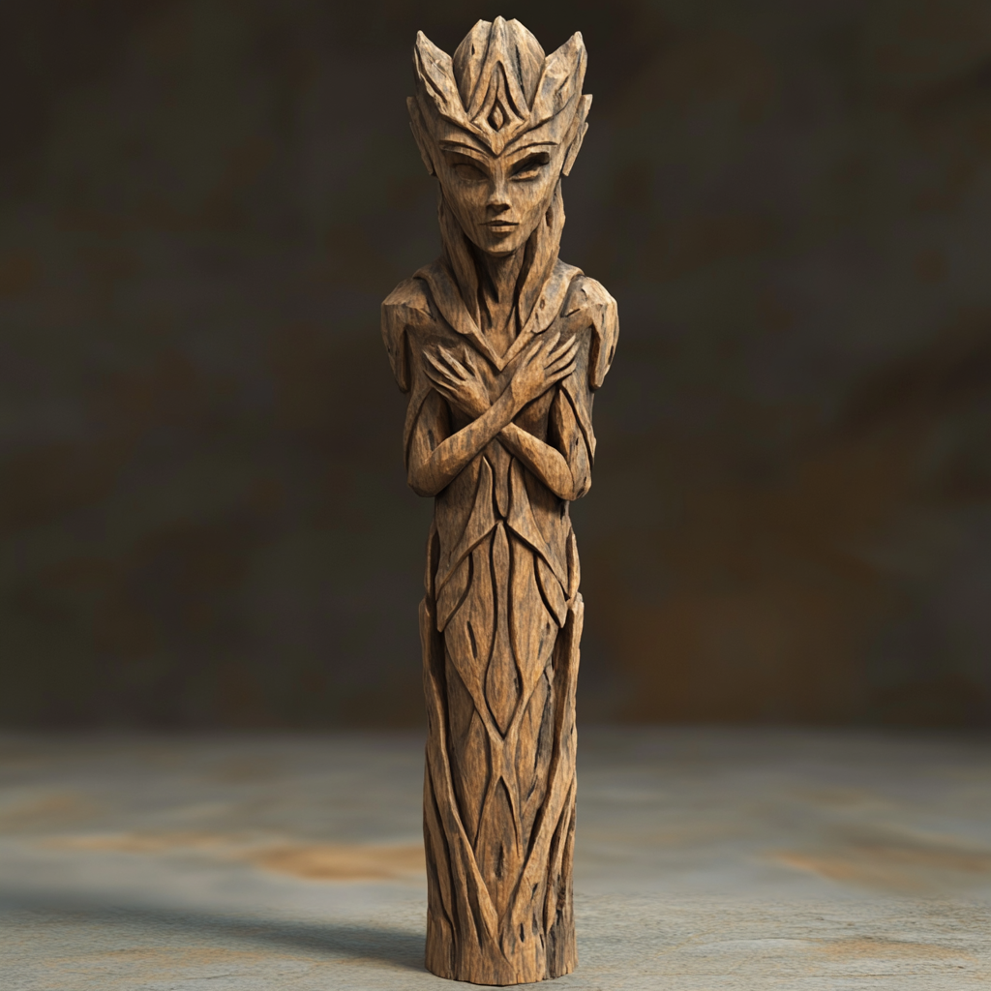

There have been many a tale over the centuries of a mysterious swamp witch known as Yaluska of the Mire. Living as her namesake would imply, deep within the Ancient Wood, where the great fertile land gives way to a massive boggy swamp, somewhere within lies an entity whose true power and intentions are unknown to all but them.

As to whether she can be put on the same level as the gods isn’t quite clear. However, in one such story it tells of her magic being so powerful that the sky up until that point had always been a hazy light orange color, always appearing how it now only looks at dawn. That is until the great witch had decided on a whim that blue was so much interesting to look at, giving us what we all know of today remained a constant in the Ancient Wood as far back as known history can take us. Tales of the mysterious witch are often told more as fables than fact, which has made discerning truth from fiction nigh impossible. The one constant that seems to persist however is that whatever Yaluska may provide, aid or otherwise, it always comes at a price. From the most desperate peasants to the greediest of nobles, many who have sought out to meet the great witch often live to have regretted it.

